Table of Contents

[1. Introduction 11](#_Toc527555757)

[2. Install 12](#_Toc527555758)

[3. Start ESP3 16](#_Toc527555759)

[4. Basic operation 19](#_Toc527555760)

[a. The main window 19](#_Toc527555761)

[b. Echogram display – Frequency channel and data type 19](#_Toc527555762)

[c. Echogram display – Colour and data range 22](#_Toc527555763)

[d. Echogram display – X and Y axes grids and units 23](#_Toc527555764)

[e. Echogram display - Vertical and horizontal profiles 23](#_Toc527555765)

[f. Cursor modes 24](#_Toc527555766)

[g. Zoom-in, zoom-out and move around the display on the Echogram 25](#_Toc527555767)

[h. The overview display 25](#_Toc527555768)

[i. Selection boxes 27](#_Toc527555769)

[j. The basic pre-processing sequence: (1) setting bottom line, (2) flagging bad transmits, and (3) defining regions 28](#_Toc527555770)

[5. Bottom line 31](#_Toc527555771)

[a. Display of the bottom line and the data under it 31](#_Toc527555772)

[b. The Bottom Inspection Display 31](#_Toc527555773)

[c. Automatic bottom detection algorithms 32](#_Toc527555774)

[i. Setting algorithm parameters 32](#_Toc527555775)

[ii. Applying the algorithm in bulk (to one or several layers) 33](#_Toc527555776)

[iii. Applying the algorithm to a section of data (selection box, and Brush Tool) 33](#_Toc527555777)

[d. Editing the bottom line manually 35](#_Toc527555778)

[i. The Classic Tool 35](#_Toc527555779)

[ii. The Spline Tool 35](#_Toc527555780)

[iii. The Erase Tool 35](#_Toc527555781)

[iv. Shifting the bottom vertically 36](#_Toc527555782)

[e. Copy the bottom line from one channel to others 36](#_Toc527555783)

[f. Saving/loading the bottom line 36](#_Toc527555784)

[i. XML 36](#_Toc527555785)

[ii. Database 36](#_Toc527555786)

[6. Bad transmits 38](#_Toc527555787)

[a. Display of bad transmit flags 38](#_Toc527555788)

[b. Automatic detection of bad transmits 38](#_Toc527555789)

[c. Manual edition of bad transmits 39](#_Toc527555790)

[d. Copy bad transmit flags from one channel to others 39](#_Toc527555791)

[e. Saving/loading the bad transmits flags 39](#_Toc527555792)

[i. XML 40](#_Toc527555793)

[ii. Database 40](#_Toc527555794)

[7. Regions 41](#_Toc527555795)

[a. Display of regions 41](#_Toc527555796)

[b. Active vs inactive regions 42](#_Toc527555797)

[c. Region parameters 42](#_Toc527555798)

[i. Name: “User defined”, “WC”, or “School” 42](#_Toc527555799)

[ii. ID 42](#_Toc527555800)

[iii. Tag 42](#_Toc527555801)

[iv. Type: “Data” or “Bad Data” 43](#_Toc527555802)

[v. Cell Width and Height 43](#_Toc527555803)

[vi. Reference: “Surface”, “Bottom”, or “Line” 43](#_Toc527555804)

[d. User-defined regions 43](#_Toc527555805)

[e. Water-Column (WC) regions 44](#_Toc527555806)

[f. School regions (school detection algorithm) 46](#_Toc527555807)

[g. Interacting with regions 47](#_Toc527555808)

[i. Deleting a region 47](#_Toc527555809)

[ii. Moving a region 47](#_Toc527555810)

[iii. Merging several regions 47](#_Toc527555811)

[iv. Modifying the boundaries of a region 47](#_Toc527555812)

[v. Modifying the parameters of a region 47](#_Toc527555813)

[vi. Copying a region to other frequencies 47](#_Toc527555814)

[h. Saving/loading regions 48](#_Toc527555815)

[i. XML 48](#_Toc527555816)

[ii. Database 48](#_Toc527555817)

[8. Handling multiple files 49](#_Toc527555818)

[a. Survey and layers 49](#_Toc527555819)

[b. Metadata attributes 49](#_Toc527555820)

[c. Editing metadata from the echogram 49](#_Toc527555821)

[d. Logbook 50](#_Toc527555822)

[e. Layer list 51](#_Toc527555823)

[f. Display of files and layers in the echogram 52](#_Toc527555824)

[g. Splitting one layer into two 52](#_Toc527555825)

[9. Basic echo-integration 54](#_Toc527555826)

[a. Echo-integration of a region 54](#_Toc527555827)

[b. Echo-integration of a transect 55](#_Toc527555828)

[10. Survey processing with the scripting module 58](#_Toc527555829)

[a. Introduction to scripts 58](#_Toc527555830)

[b. Folder for scripts and survey processing results 59](#_Toc527555831)

[c. The scripting module 60](#_Toc527555832)

[d. Script format 61](#_Toc527555833)

[i. Root organization 61](#_Toc527555834)

[ii. The <survey ... /> element 62](#_Toc527555835)

[iii. The <options ... /> element 63](#_Toc527555836)

[iv. The <cal ... /> element 64](#_Toc527555837)

[v. The <regions\_WC ... /> element 65](#_Toc527555838)

[vi. The <algos> element 65](#_Toc527555839)

[vii. The <snapshot ... > element 68](#_Toc527555840)

[e. Survey processing results 69](#_Toc527555841)

[i. Results metadata (Sheet1) 69](#_Toc527555842)

[ii. Stratum summary (Sheet2) 69](#_Toc527555843)

[iii. Transect summary (Sheet3) 70](#_Toc527555844)

[iv. Sliced transect summary (Sheet4) 71](#_Toc527555845)

[f. Display survey processing results 71](#_Toc527555846)

[11. Advanced handling 74](#_Toc527555847)

[a. Configurations 74](#_Toc527555848)

[b. Set paths 74](#_Toc527555849)

[c. File input 74](#_Toc527555850)

[d. Import/export 74](#_Toc527555851)

[i. GPS/attitude 74](#_Toc527555852)

[ii. Bottom 74](#_Toc527555853)

[iii. Regions 74](#_Toc527555854)

[iv. Echogram 74](#_Toc527555855)

[v. Single targets and tracked targets 74](#_Toc527555856)

[12. Calibration 75](#_Toc527555857)

[CW mode: 75](#_Toc527555858)

[13. Other algorithms 77](#_Toc527555859)

[a. Denoising 77](#_Toc527555860)

[b. School classification 77](#_Toc527555861)

[c. Single Targets detection 77](#_Toc527555862)

[d. Target tracking 77](#_Toc527555863)

[Appendix A: Algorithms 79](#_Toc527555864)

[1. Bottom detect v2 79](#_Toc527555865)

[a. Location 79](#_Toc527555866)

[b. Description 79](#_Toc527555867)

[2. Bad Pings Detection 80](#_Toc527555868)

[a. Location 80](#_Toc527555869)

[b. Description 80](#_Toc527555870)

[Appendix B: Echo-integration 85](#_Toc527555871)

[1. Preliminary definitions 85](#_Toc527555872)

[2. Backscattering coefficients for a cell 85](#_Toc527555873)

[3. Area and volume backscatter for a region 86](#_Toc527555874)

[4. Sliced area backscatter for a transect 86](#_Toc527555875)

[5. Volume backscatter for a file 86](#_Toc527555876)

[6. Areal backscatter for a file 87](#_Toc527555877)

[7. Volume backscatter for a transect 87](#_Toc527555878)

[8. Areal backscatter for a transect 87](#_Toc527555879)

[9. Areal backscatter for a stratum 87](#_Toc527555880)

[14. References 88](#_Toc527555881)

# Introduction

ESP3 is an **open-source** software package developed by the deep-water fisheries acoustics team at NIWA (Wellington, New Zealand) for visualizing and processing **fisheries acoustics data from** single-beam and split-beam echosounders.

ESP3 is built in priority around **SIMRAD EK60 and EK80 data** (.raw) but also supports a few other formats to some extent: NIWA CREST, Furuno FCV-30 and ASL AZFP. The focus of the software is the processing of fisheries acoustic surveys, with attention to reproducibility and consistency. A range of data processing operations are possible including calibration, echo-integration, automated bad pings identification, automated bottom detection, single targets identification and tracking, school detection, etc.

ESP3 is written in **MATLAB**. With the source code, it can be run from a standard MATLAB environment provided the appropriate version and toolboxes are installed. The source code is under Git version controlling and hosted at <https://bitbucket.org/echoanalysis/esp3>, at the date of writing this document. Periodically, a **compiled version** is created out of the latest stable release. This is an individual ESP3 application for Windows (64bits platforms) that can be run without the MATLAB software or license.

We recommend using a compiled version, even though it may not include the latest features developed by the team. Please visit <https://bitbucket.org/echoanalysis/esp3> to find the latest version of the software (source and/or compiled), as well as the most up-to-date guide. The source and compiled versions operate in the same manner, so this guide applies to both, at the exception of the install and start sections, which only refer to the compiled version.

# Install

This section provides information to download and install the compiled version of ESP3 only, and for the version indicated at the top of this document. See the ESP3 online page for the relevant information on the MATLAB version or other compiled versions.

First, download and install the latest version of the (free) MATLAB Runtime at <https://au.mathworks.com/products/compiler/matlab-runtime.html> (Figure 1).

Next, download the latest version of the installer for the ESP3 compiled version on SourceForge at <https://sourceforge.net/projects/esp3/files/latest/download> (Figure 2). Note that earlier compiled versions are also available at <https://sourceforge.net/projects/esp3/files/>.

Finally, run the installer and follow the instructions (Figure 3-7).

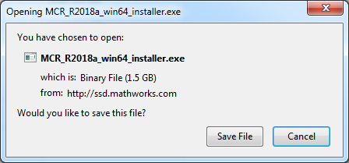

Figure : MATLAB Compiler Runtime R2016a window

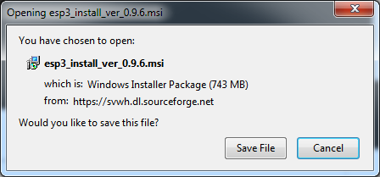

Figure : ESP3 download window

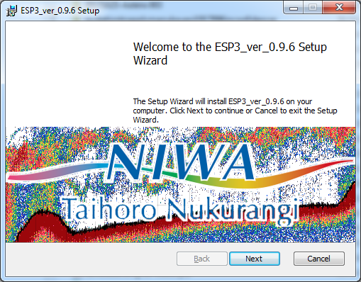

Figure : ESP3 install window 1

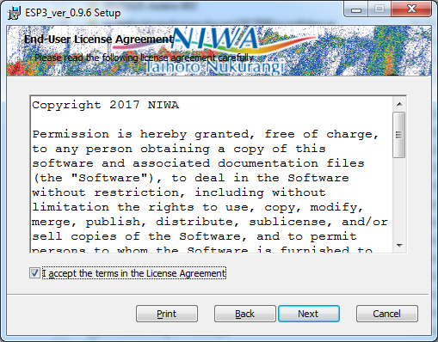

Figure : ESP3 install window 2

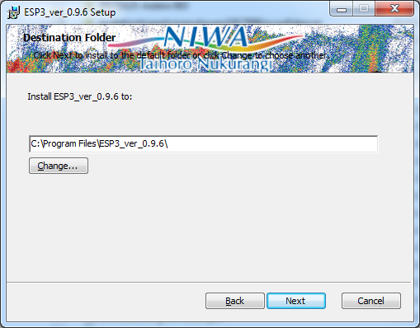

Figure : ESP3 install window 3

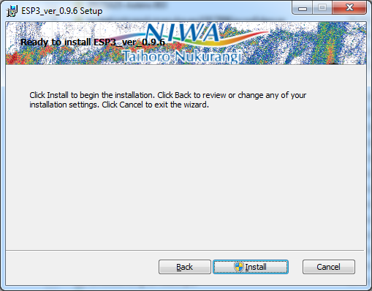

Figure : ESP3 install window 4

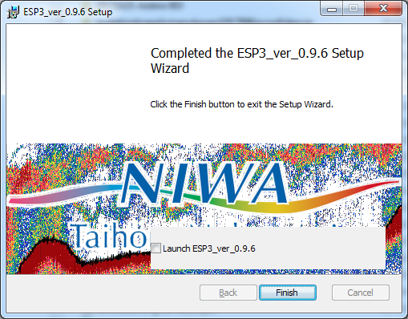

Figure : ESP3 install window 5

# Start ESP3

Run ESP3.exe from the ESP3 root folder (normally in the “Program Files” folder). The ESP3 **console** (Figure 8) and **main window** (Figure 9) appear. There is no user interaction with the console, as it is only used to display information, warning messages or error messages when using ESP3. The rest of this guide applies to the main window.

In the Menu, select File(s) then Open file.

Navigate to the \example\_data\ek60\ folder that accompanies ESP3. It contains seven raw data files of the example dataset.

Open the first file in the list, i.e. tan1505-D20150428-T010855.raw (Figure 10).

Since EK60 raw data files can hold data from several frequencies, a window appears listing frequencies available and prompting the user to select which ones to open (Figure 11). Select all and click OK.

ESP3 will load data from all frequencies in the file and the data for a default frequency will be displayed as a separate tab in the main window (Figure 12).

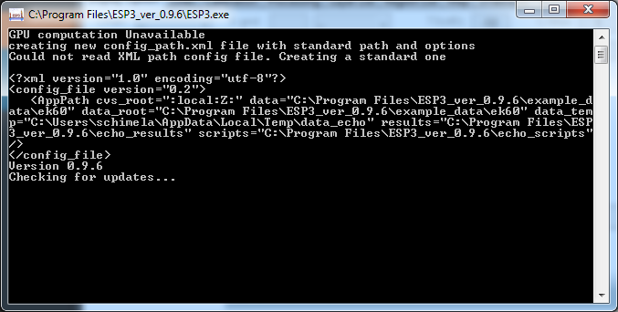

Figure : ESP3 console

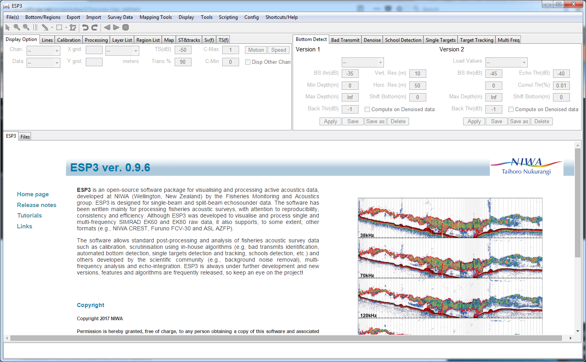

Figure : ESP3 main window at opening

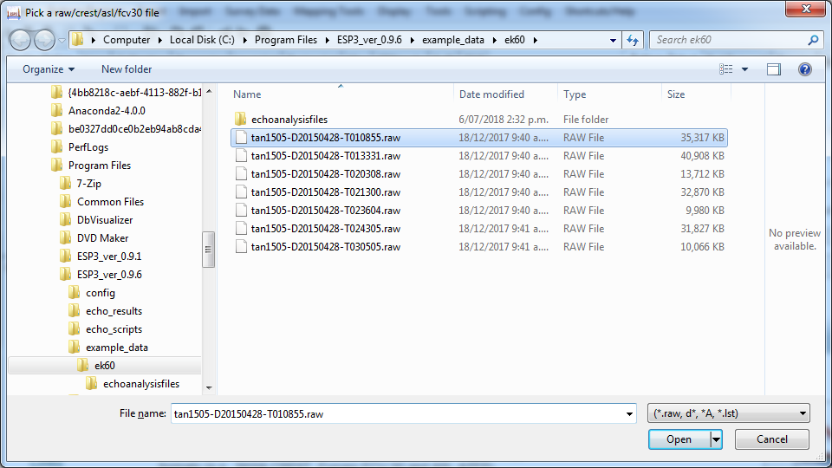

Figure : Open the first file in the example dataset

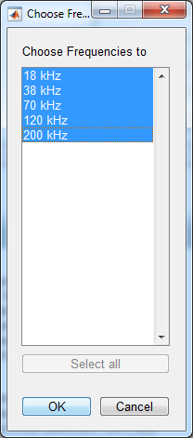

Figure : Frequencies to load

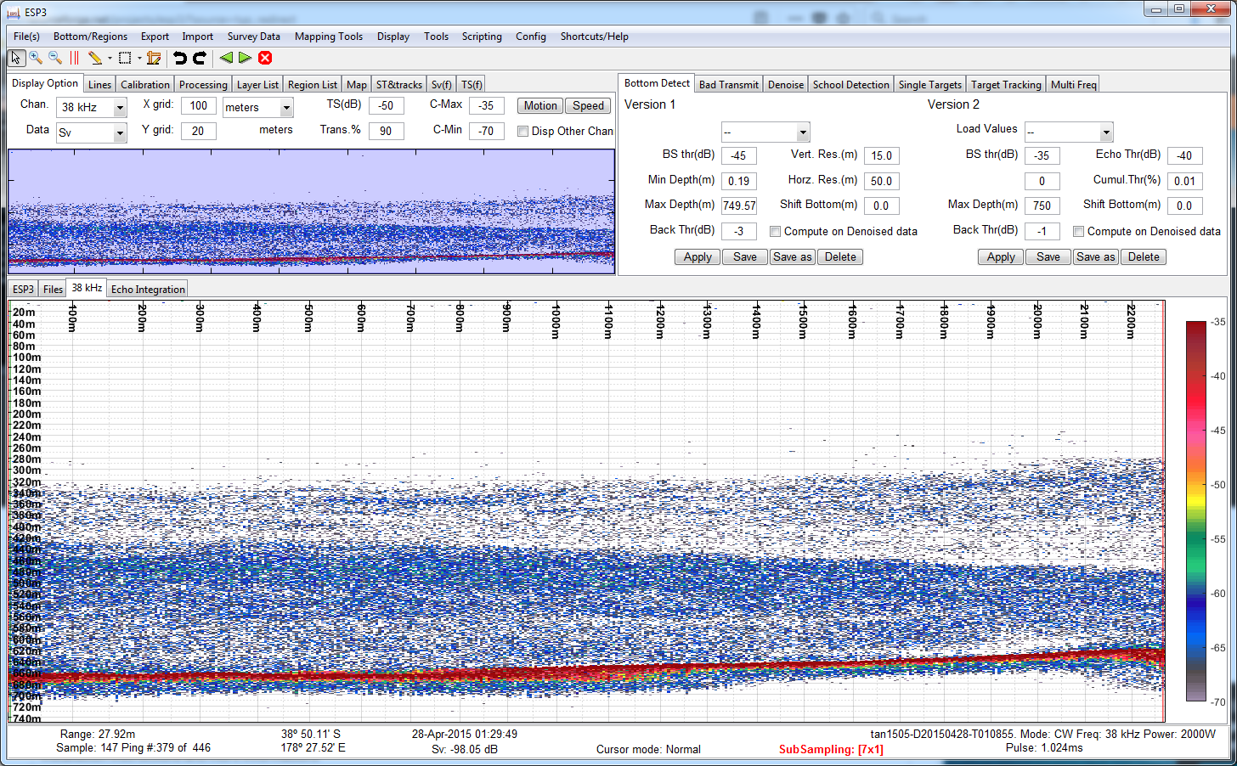

Figure : ESP3 after loading one file

# Basic operation

## The main window

ESP3’s main window is split into 6 components, from top to bottom (Figure 13):

* The Menu allows access to every function of ESP3.
* The Tools bar is a series of icons allowing fast access to various Cursor Modes, as well as some basic commands.
* The Control Panel on the upper-left is composed of tabs allowing a variety of display windows (Overview, Maps, Vessel motion, multi-frequency target strength, etc.), display options (frequency selection, data variables, etc.), actions (calibration, application of algorithms in bulk, etc.), lists (regions, layers, etc.). It is where ESP3 is mostly controlled from.
* The Algorithms Panel on the upper-right is composed of tabs allowing setting parameters for the various algorithms available and applying them to the data.
* The Main Panel in the bottom-center is used as the main data display (echograms, and results of echo integration), but also for list of files, Logbook, and help.
* The Metadata Panel at the bottom shows various information about the current file displayed, and about the ping and sample corresponding to the location of the mouse cursor when on the Echogram.

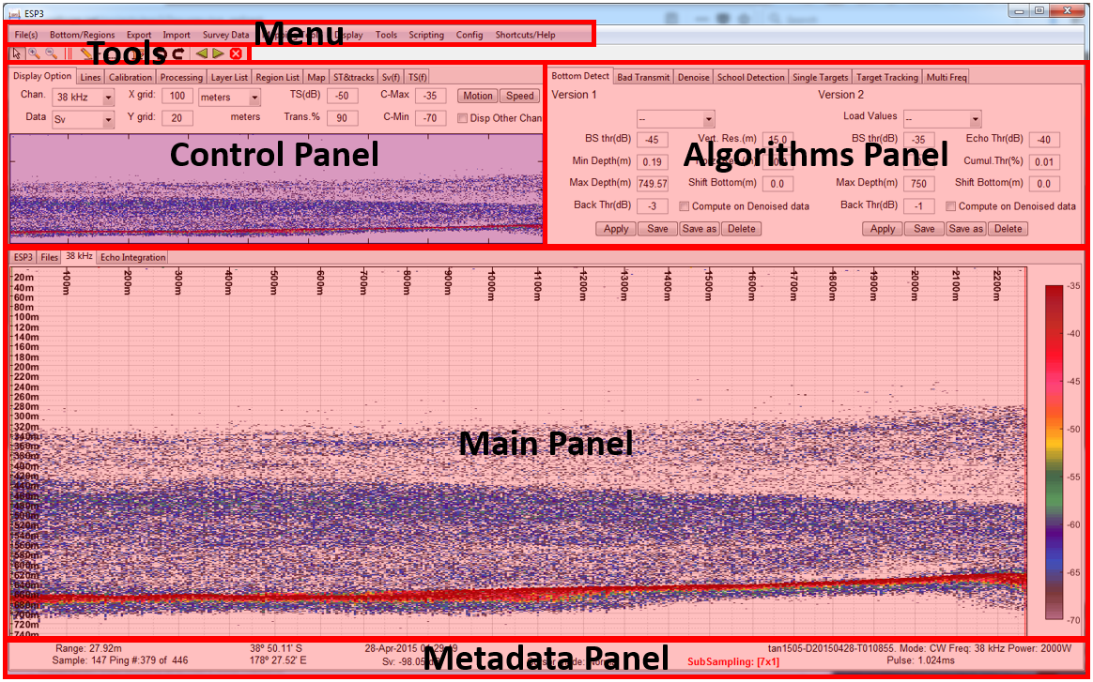

Figure : ESP3 main window components

## Echogram display – Frequency channel and data type

The main panel is primarily used as a display of the Echogram of a file loaded into the software. An echogram is a colour-coded image of the recorded acoustic data where each column represents one successive “ping” with the beginning of the recording at the top.

Be aware that, at any time, the echogram shows **only one data type** for **only one of the frequency channels in the file**.

The frequency channel displayed by default is 38 kHz (if it was loaded). **To select a different frequency**:

* Go to the Control Panel, and under the Display Option tab, use the drop-down menu next to Chan. (Figure 14).
* Alternatively, use the shortcut F to toggle between frequencies.

To show all frequency channels concurrently, check the checkbox titled Disp Other Channels in the Control Panel, under the Display Option tab (Figure 14). The echogram for all channels will open a as a separate window (Figure 15). Right-click on the All Channels window and select Change orientation to change the stacking of the echograms (Figure 16).

The data type displayed by default is **the volume backscattering strength $S_{v}$**  in dB re 1 m-1 (MacLennan et al. 2002). **The other data types available** directly after loading the file are, in the case of EK60 data:

* Power: the raw level of the data samples in the files (in dB), from which $S_{v}$ is calculated.
* Angle Across and Angle Along: angles in the across- and along-track directions (in degrees) for each data sample.
* TS (uncompensated): Target Strength in dB re 1 m2 (MacLennan et al. 2002), calculated from $S_{v}$ and the Target Strength parameter TS(dB) that is also editable in the Display Option tab (Figure 14). Note that this value is not compensated for antenna directivity (i.e. beam pattern), hence the “Unc” in the variable name.

To select a different data type:

* Go to the Control Panel, and under the Display Option tab, use the drop-down menu next to Data (Figure 14).
* Alternatively, use the shortcut E to toggle between data types.

Note that some algorithms create new data types that are then accessible in this drop-down menu.

Note that changes in data type displayed will apply to the All-Channels window as well.

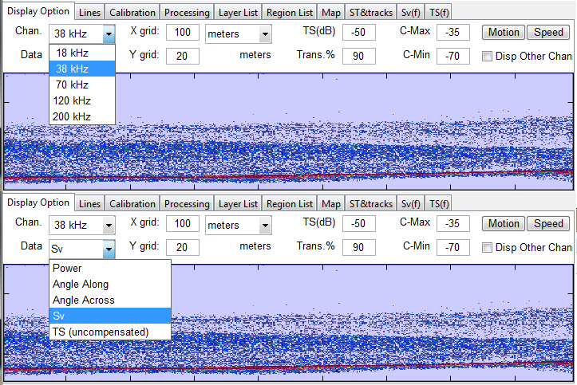

Figure : Changing frequency (top) or data type (bottom) in the Control Panel

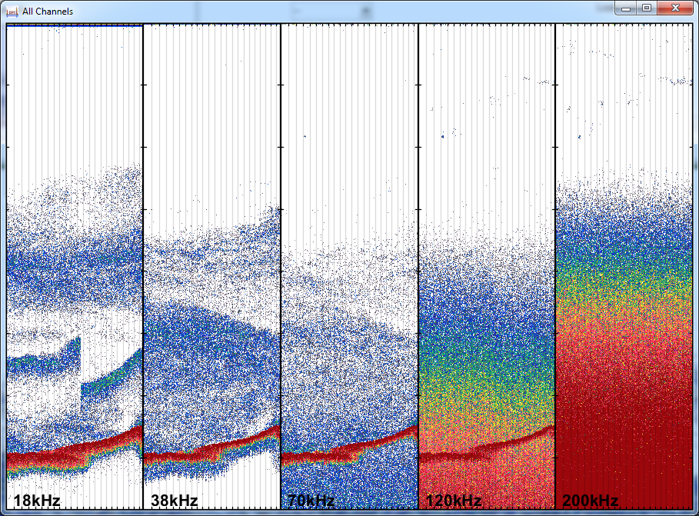

Figure : All-channels window

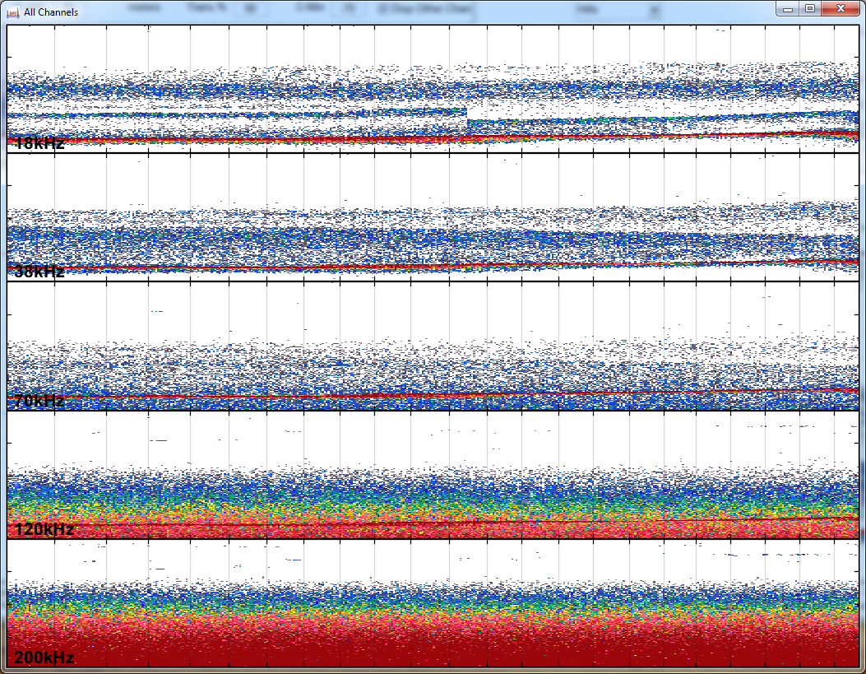

Figure : All-channels window, with echograms stacked vertically

## Echogram display – Colour and data range

**The colour legend** at the right of the Echogram shows the colour scheme used to represent data, as well as the high and low limits of the colour scale (Table 1).

Table : Data types available by default, with default high and low limits for display

|  |  |  |  |
| --- | --- | --- | --- |
| **Data type** | **Unit** | **Low limit** | **High limit** |
| Power | dB | -200 | 0 |
| Sv | dB re 1 m-1 | -75 | -35 |
| TS Unc | dB re 1 m2 | -60 | -30 |
| Angle across & angle along | degrees | -10 | 10 |

Data that are lower that the low limit and data that are higher than the high limit are displayed differently:

* Data that are **lower than the low limit** are coded in **white** (low-limit “cut-off”). This implies that you cannot see data lower than the low limit.
* Data that are **higher than the high limit** are coded **with the same colour as that of the high limit** (high-limit “saturation”). This implies that you can see but not tell the difference between data that are higher than the high limit.

It is thus very important to adjust the colour scale to your needs, which you can do by:

* Going to the Control Panel, and under the Display Option tab, modify values for C-Min and C-Max (Figure 14), or alternatively;
* Using the shortcuts + (plus) and – (minus) to shift the colour scale higher or lower (by steps of 1 unit of the data type displayed).

**To change the colour scheme** itself, go to the Menu and select Display, then Colormap, and select one of the options available. Alternatively, use the shortcut C to toggle between colour schemes. Note that in the “esp2” colour scheme, the low limit is coloured in black and so are the data lower than that limit.

Note that changes in the colour scale limits and the colour scheme will apply to the All-Channels window as well.

You can hide the colour legend by going to the Menu and select Display, then uncheck Show Colorbar.

## Echogram display – X and Y axes grids and units

Since the echogram is an image of the recorded acoustic data where each column represents one successive “ping” with the beginning of the recording at the top, the original unit for the X-axis is the number of pings since the start of the record, and the original unit for the Y-axis is the time since beginning of the record (with 0 at the top and increasing downwards). However, those values are converted by default to distance (in m) for both axes.

Note that since vessel speed and/or ping rate can change through a record, the graph grid in the X-axis can be irregular. The X-axis unit can be changed to ping number or seconds since the start of the file, using the drop-down menu next to X grid in the Display Option tab of the Control Panel (Figure 17).

The grid steps for both axes can be modified by entering a new value in the box next to the X grid or Y grid label, respectively.

Note that changes in the X-axis units or grid step will apply to the All-Channels window as well.

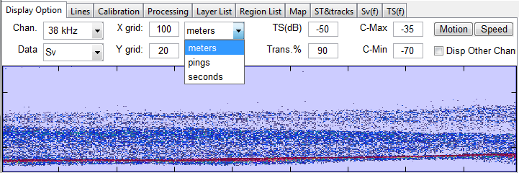

Figure : Changing X-axis unit in the Control Panel

## Echogram display - Vertical and horizontal profiles

A Vertical Profile can be displayed on the left of the echogram by left-clicking on the Y-axis and dragging towards the right to adjust its size (Figure 18). This profile represents the data record for the ping where the cursor currently points at in the Echogram. A horizontal, dashed blue line indicates the range where the cursor currently points at in the Echogram.

Similarly, a Horizontal Profile can be displayed on the top of the echogram by left-clicking on the X-axis and dragging downwards to adjust its size (Figure 18). This profile represents the data across all pings for the range where the cursor currently points at in the Echogram. A vertical, dashed blue line indicates the ping where the cursor currently points at in the Echogram.

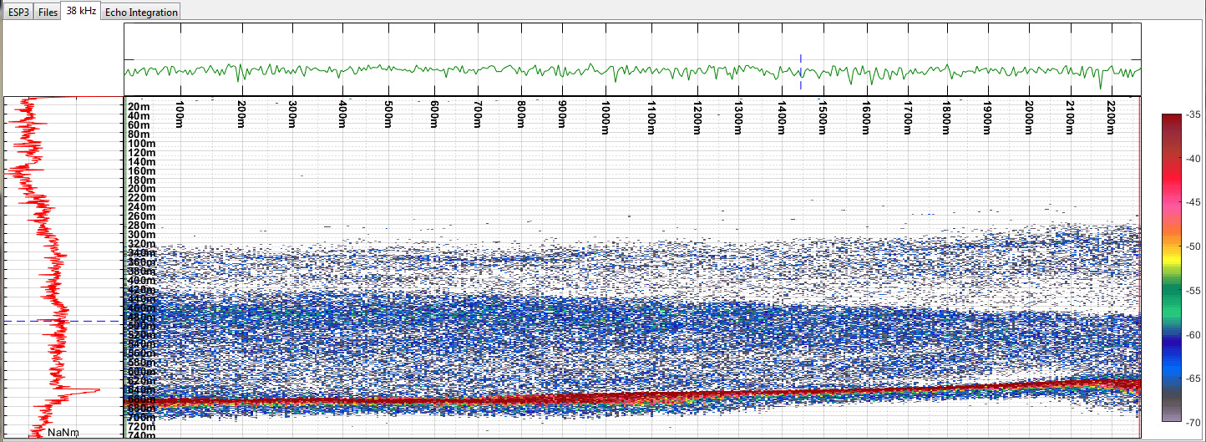

Figure . Echogram with the vertical profile in red on its left and the horizontal profile in green on top.

## Cursor modes

ESP3 has seven “modes of operation”, allowing the user to interact with the Echogram in different manners for different purposes (Table 2). The usage of the mouse buttons on the Echogram differs between each mode. The current Mode is indicated:

* In text in the middle of the Metadata Panel;
* By the aspect of the mouse cursor when it is over the Echogram, and;
* By which icon in the Tools bar is highlighted, if any (Figure 19).

Table : Modes of operation

|  |  |  |  |
| --- | --- | --- | --- |
| **Name** | **Keyboard**  **Shortcut** | **Icon** | **Description** |
| Normal | 0 | D:\MATLAB\REPOS\ESP3\icons\tool_pointer.png | Default mode. Used to interact with existing objects in the Echogram (regions and bottom line) and create selection areas to allow the application of some features and algorithms on limited portions of data. |
| Zoom In | 1 | D:\MATLAB\REPOS\ESP3\icons\tool_zoom_in.png | Used for zooming in on the Echogram. |
| Zoom Out | Shift+1 | D:\MATLAB\REPOS\ESP3\icons\tool_zoom_out.png | Used for zooming out on the Echogram. |
| Bad Transmit | 2 | D:\MATLAB\REPOS\ESP3\icons\bad_trans.png | Used to flag/unflag pings as “bad transmits”. |
| Edit Bottom | 3 | D:\MATLAB\REPOS\ESP3\icons\edit_bot.png | Used to create/edit/delete the “bottom line”. Several tools are available by clicking on the small down arrow next to the symbol in the Tools bar. |
| Create Region | 4 | D:\MATLAB\REPOS\ESP3\icons\create_reg.png | Used to create (and edit/delete) regions for echo-integration. Several types of regions are available by clicking on the small down arrow next to the symbol in the Tools bar. |
| Measure Distance | 5 | D:\MATLAB\REPOS\ESP3\icons\ruler.png | Used to measure distances. |



Figure : Tools bar with the Normal mode active

## Zoom-in, zoom-out and move around the display on the Echogram

In all modes of operation, use the following mouse and keyboard actions to change the view on the Echogram:

* **To zoom-in**, scroll up with the mouse scroll button.
* **To zoom-out**, scroll down with the mouse scroll button.
* **To pan around the display**, use the keyboard's up/down/left/right arrow keys, or the keys W (up), S (down), A (left), and D (right).

The zoom-in and zoom-out modes of operation have additional zoom actions.

In zoom-in mode (shortcut 1), the following mouse commands are possible:

* Left-click or right-click to zoom in one step.
* Left-click, drag & release on the Echogram to create a zoom-in box.
* Right-click, drag & release or Ctrl + left-click, drag & release to create a zoom box that spans all pings currently shown on the Echogram.

In zoom-out mode (shortcut shift+1), the following commands are possible:

* Left-click to zoom-out one step.
* Right-click or Ctrl + left-click or slow double left-click to zoom all the way out.

Note that changes in the section of data displayed on the echogram through zooming in/out and panning will apply to the All-Channels window as well.

## The overview display

The Overview display is the smaller display in the Control Panel under the Display Option tab (Figure 14). While this display shows the entire file/layer at all times, the blue box superimposed on it represents the extent of data currently shown in the Echogram (Figure 20) and on the All-Channels window.

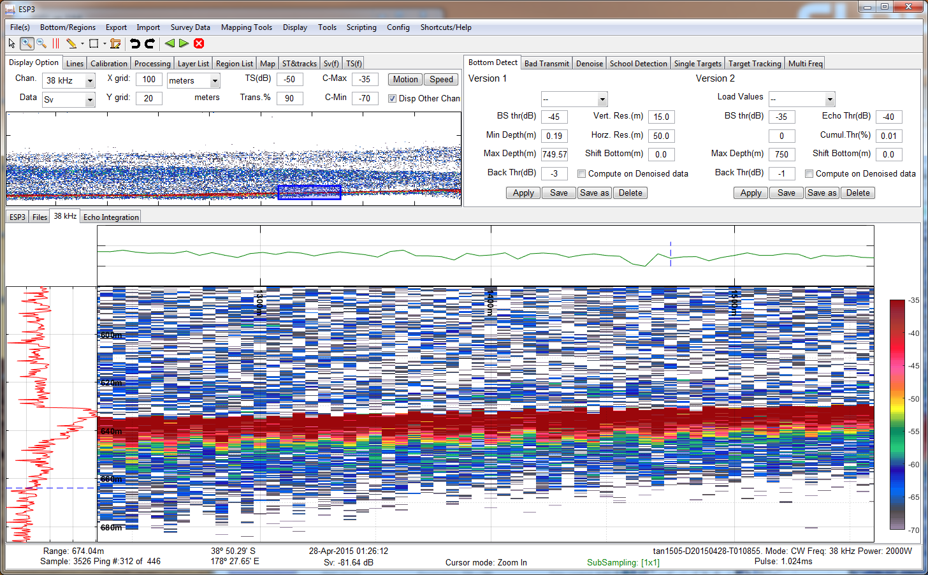

Figure : Main window, after zooming in on the Echogram. The overview display still shows the full data, but the extent of the main display shows as a blue box on the overview display.

Using the Overview display and the blue box is a convenient way to change the view on the Echogram. The blue box can be “moved around” the Overview Display with a left click and drag, thus allowing to view different parts of the Echogram while conserving the same level of zoom.

You can create a new blue box on another part of the Overview Display with a left-click outside of the current blue box, hold, drag, and release.

Because of the convenience of manipulating the blue box in the Overview Display to rapidly change the data displayed on the Echogram, it is a good idea to undock it from the Control Panel to always have it on the screen, particularly if your machine has multiple screens. To do this, right-click anywhere on the Overview Display to open its contextual menu and select Dock/Undock MiniAxes to undock it from the Control Panel and into its own separate window (Figure 21). The undocked Overview Display window can be docked back into the Control Panel by simply closing it.

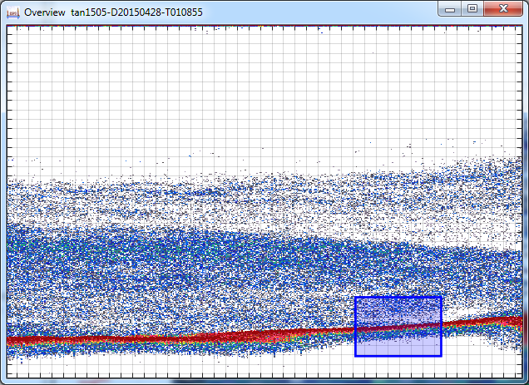

Figure : Overview display, after being undocked

## Selection boxes

Selection boxes allow the application of algorithms to select parts of the data.

To create a selection box, get into Normal mode (shortcut 0), then either:

* Hold the Shift key and left-click-and-drag around the desired section of the echogram to create a **rectangular selection box** (Figure 22, top); or
* Hold the Ctrl key and left-click-and-drag around the desired section of the echogram to create a **horizontal selection box spanning all pings in the layer currently loaded** (Figure 22, bottom).

Once a selection box has been created, it is possible to move it by simply left-click and dragging while in normal mode (shortcut 0).

To delete a selection box, hold either the Shift or Ctrl key and left-click anywhere on the echogram.

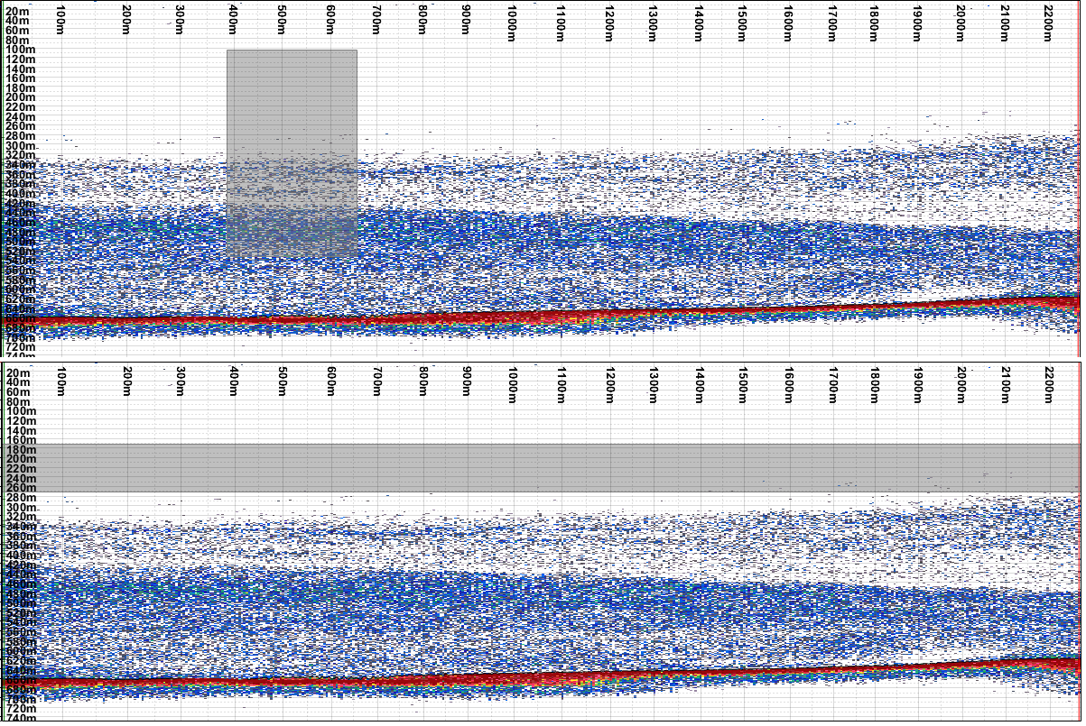

Figure : Examples of rectangular selection box (top), and horizontal selection box (bottom)

## The basic pre-processing sequence: (1) setting bottom line, (2) flagging bad transmits, and (3) defining regions

The main purpose of ESP3 is echo integration, that is, the calculation of a total area or volume backscattering coefficient for a set of samples over a range of pings. Typically, a set of samples for echo integration would be all samples within a user-defined **region of interest** in the echogram (for example, a fish school), minus all samples that one wishes to exclude from the calculation. The two most common types of such unwanted samples are:

* The samples making up the **bottom echo** (because they are so energetic that even one sample can dramatically skew the results), and;
* The samples making up pings that were **corrupted by bubbles at the transducer face** (because they tend to display low energy where the data should have displayed high energy in the presence of targets).

In ESP3, regions of interest are called **“regions”** and there are several approaches to define them, depending on the user objectives. The issue of the bottom echo is tackled by allowing the definition of a sample in every ping below which all data samples are to be ignored in the integration; a lower bound termed the **“bottom line”**. ESP3 offers algorithms to automatically or semi-automatically set this bottom line as well as a range of tools to examine the results of this algorithm and to manually set, modify, shift, remove and save the bottom line. A number of tools are also available to flag pings corrupted by bubbles as **“bad transmits”**, which excludes all their samples from any integration calculations.

Setting the bottom line, flagging corrupted pings as bad transmits, and defining regions for integration thus form the core of data pre-processing in ESP3, usually in that order. Figure 23 shows a typical aspect of ESP3 with those elements defined.

Note that the bottom line, the bad transmits flags, and the regions are defined separately for each frequency channel in a file (Figure 24), although there are options to copy those across to the other channels.

For all actions in setting, modifying or deleting the bottom line, bad transmits or regions, see the next sections.

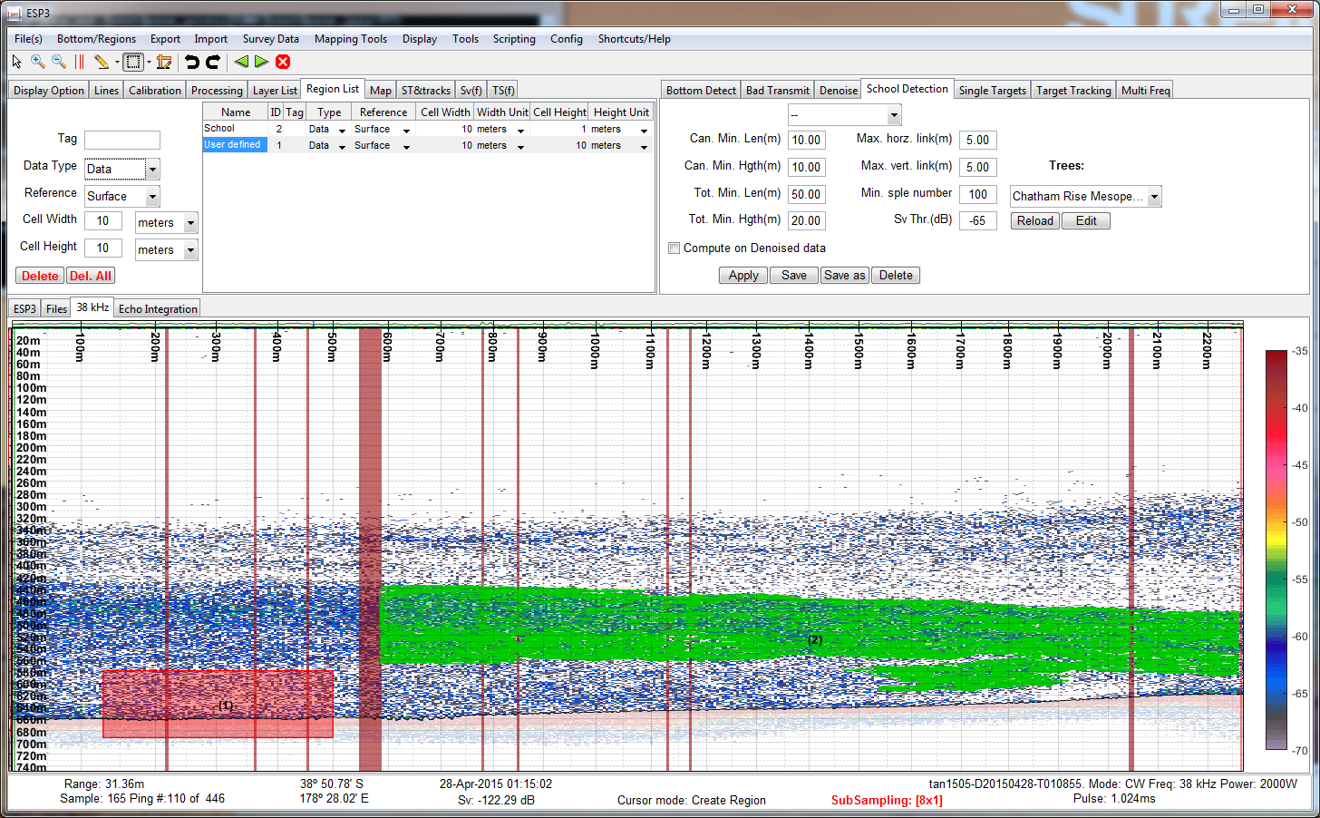

Figure : Main window showing a file with bottom line set, bad transmits identified (vertical red lines) and two types of regions defined: (1) a “user-defined” rectangular-shaped region (in red, meaning it is the currently active region), and (2) an automatically-generated “School” region from the school-detection algorithm (in green)

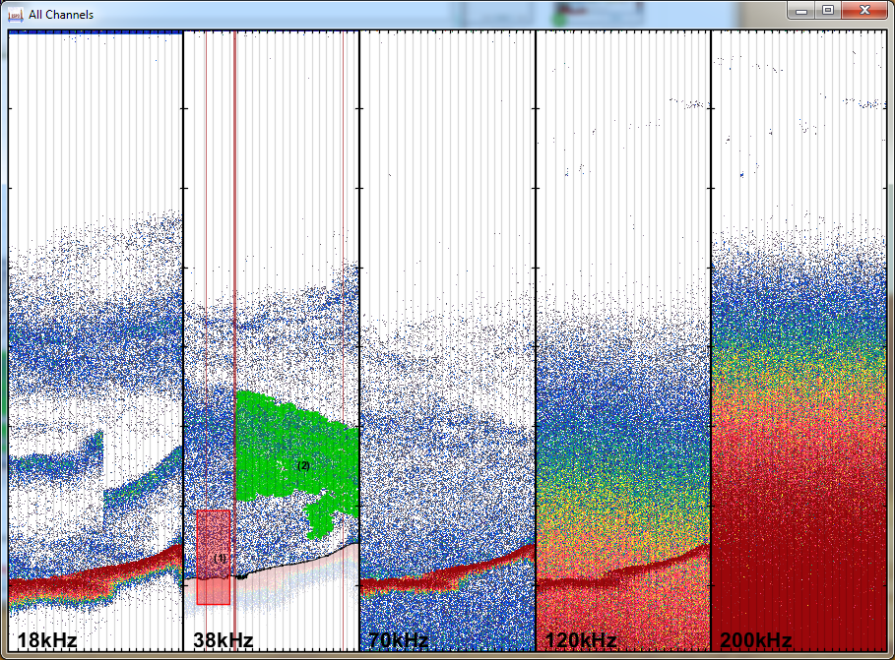

Figure : The bottom line, bad transmit flags, and regions are only defined for the channel in the echogram, as shown by this All-channels window corresponding to the previous figure

# Bottom line

## Display of the bottom line and the data under it

The bottom line itself shows as a black line on the Echogram (Figure 25), but only if the option Display bottom in the Display section of the Menu is selected.

Data below the bottom line is displayed with a level of transparency that can be set next to the Trans.% parameter in the Display Option tab of the Control Panel (Figure 14). Note that this is only valid if option Display Under Bottom Data in the Display section of the Menu is selected (shortcut B). A Trans.% value of 100 will completely hide the data below the bottom line (Figure 25).

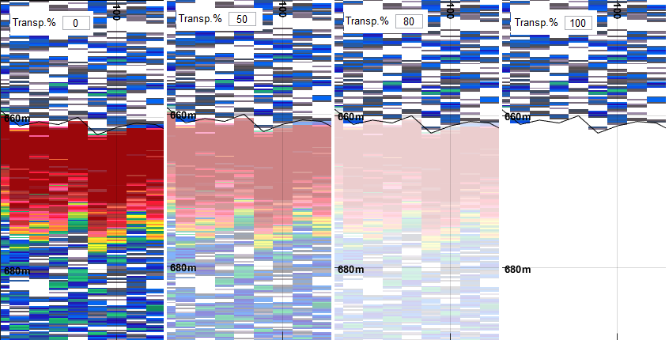

Figure : Zoomed-in view on the echogram with various levels of transparency. The bottom line shows as a black line

## The Bottom Inspection Display

The Bottom Inspection Display is a graph taking the place of the Horizontal Profile to show the average level of the three samples above the bottom line (Figure 26). Peaks on this curve indicate the pings with a high energy just above the bottom line. Red circles indicate those peaks which are significantly higher than normal. This display allows the user to quickly spot any ping where the bottom line may have been defined slightly lower than the start of the bottom echo. We recommended to have this display active when editing the bottom.

To show the Bottom Inspection Display, simply get into Edit Bottom mode. The Horizontal Profile automatically turns into the Bottom Inspection Display when in this mode.

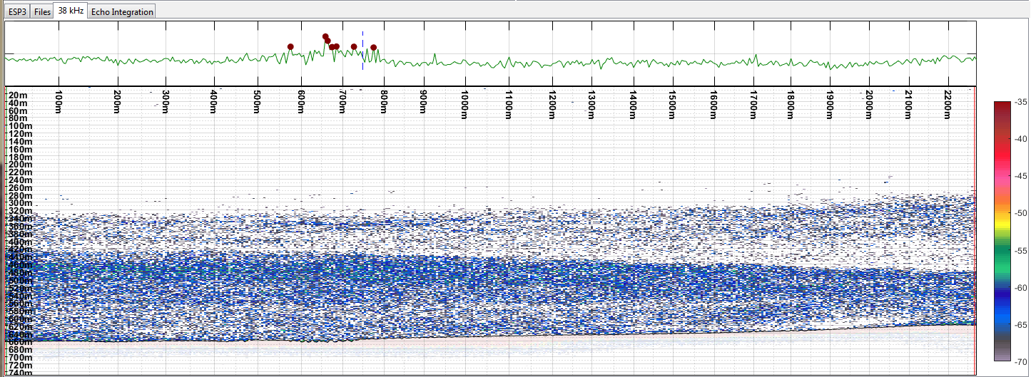

Figure : Echogram with Bottom Inspection Display above. The display indicates an extended area where the bottom line might be lower than the start of the bottom echo. Note how the red circles bring attention to some peaks, but unmarked others may need inspection too.

## Automatic bottom detection algorithms

### Setting algorithm parameters

There are two algorithms to define the bottom line automatically: the historical version 1 and the more recent version 2, the parameters of which are accessible from the Bottom Detect tab in the Algorithms Panel (Figure 27). We recommend the use of the more recent version.

The Bottom Detection V2 algorithm has 8 parameters:

* The **“Compute on Denoised data”** parameter (denoised), which controls whether the algorithm is applied to the normal data or after denoising.
* The **“Minimum Depth”** and **“Maximum Depth”** parameters cropping the data to be analysed as a function of depth.
* The **“BS Threshold”** (thr\_bottom) parameter that controls for which pings will the algorithm be applied to. This threshold is to prevent detecting a bottom in pings where the bottom was out of data range, or data where cavitation or other technical issue prevented the recording of a strong bottom echo. Use a sufficiently low “BS Threshold” to force the algorithm to be applied to all pings even if they show a weak bottom echo. Make “BS Threshold” higher if you wish to prevent the algorithm from being applied to pings that don’t have a clear bottom echo.
* The **“Echo Threshold”** parameter (thr\_echo), which controls which samples within a ping are to be omitted from the detection process in order to avoid detecting water-column targets as the bottom. Increase the value from the default -35 dB to force the algorithm to omit strong water-column echoes.
* The **“Cumulative Threshold”** parameter (thr\_cum), which defines the cut-off point in the cumulative signal where to find the detected bottom. Appropriate values for this parameter range between 0.01 and 1. The higher this parameter, the lower in the bottom echo will the bottom sample be detected.
* The **“Back-step Threshold”** parameter (thr\_backstep), which initiates a recursive back-stepping so as to find the closest sample from the initial detection that represents a significant step-up in signal strength. Use 0 to prevent the algorithm from back-stepping. Lower this value to -3, or -5, or further, when the signal above the bottom is rather strong (sidelobe artefact, for example).
* The **“Shift Bottom”** parameter (shift\_bot) to apply a constant distance shift after the final bottom sample has been detected.

The algorithm is fully described in Appendix.

About loading/saving/overwriting/deleting settings: XXX

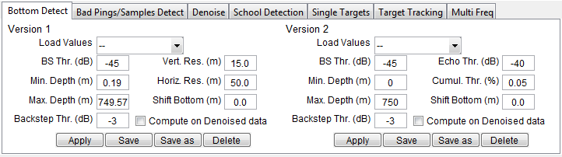

Figure : “Bottom Detect” tab in the Algorithms Panel, with default parameters (Min Depth and Max Depth are calculated from the data)

### Applying the algorithm in bulk (to one or several layers)

There are two ways to apply the bottom detect algorithms to one or several layers, both of which will apply the selected algorithm with the settings as they show in the Algorithms Panel:

* Click on the Apply button in the same tab as the settings in the Algorithms Panel (Figure 27). This will apply the algorithm to the file/layer currently loaded and displayed on the echogram.
* Go to the Processing tab in the Control Panel (Figure 28), check the appropriate check box (“Bottom Detection V1” or “Bottom Detection V2”) and choose the appropriate button to apply the algorithm either to the file/layer currently displayed (“Apply to current layer”), to all files/layers that have been loaded (“Apply to all loaded layers”), or to a set of files that have not been loaded yet (“Select \*.raw files”).

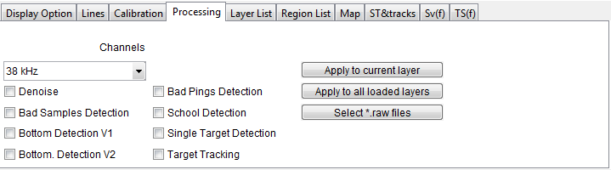

Figure : The Processing tab, in the Control Panel, allows applying one or several algorithms to one or several layers or files.

The first approach is useful to test the results of the algorithm with different settings, making use of the keyboards shortcuts Ctrl+Z and Ctrl+Y to respectively undo and re-do an application of the algorithm, until appropriate settings have been found. The second approach is then useful to apply the algorithm with these final settings to an entire survey (possibly along with other algorithms).

### Applying the algorithm to a section of data (selection box, and Brush Tool)

There are also two ways to apply either of the two bottom-detect algorithms to sections of the layer currently loaded. Again, these make use of the settings as they show in the Algorithms Panel.

The first approach is to create a selection box to the part of echogram where one wishes to apply the algorithm. Then, while in Normal mode (shortcut 0), right-click on the selection box and choose Apply Algorithm, then Bottom Detection V1 or Bottom Detection V2 (Figure 29).

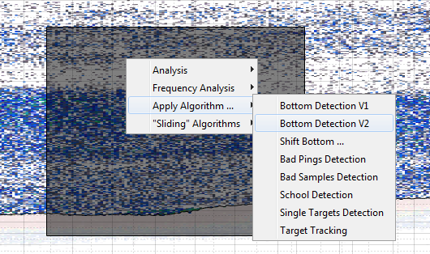

Figure : Options available after right-clicking on a selection box

The second approach is the Brush tool, available from the Tools bar by clicking on the down-arrow next to the icon for the Edit Bottom mode (Figure 30). The mouse pointer on the Echogram changes to a large straight cross.

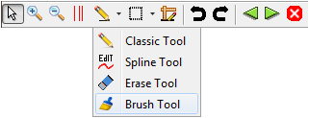

Figure : Accessing the Brush tool in the Tools bar

The Brush Tool allows applying the bottom-detect algorithm V2 on any section of the echogram that is being left-clicked on. The algorithm is applied on the fly on the pings interval and the range interval indicated by the red square surrounding the pointer (Figure 31). You can hold down the left button of the mouse and drag the pointer over the rest of the bottom echo (effectively “brushing” the bottom echo) to apply the algorithm to a more extended area.

Right-click on the Echogram when the Brush tool is on to change the size of these intervals (the size of the “brush”).

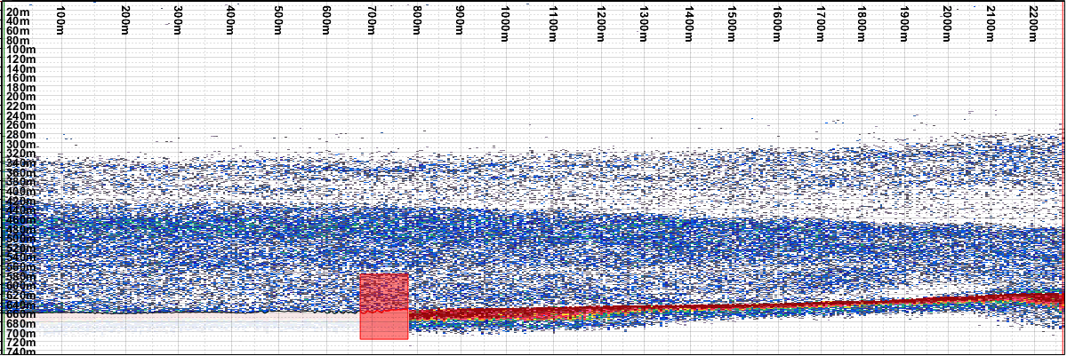

Figure : Using the Brush Tool on the echogram

You can use the keyboards shortcuts Ctrl+Z and Ctrl+Y to undo and re-do, respectively, any application of the algorithm on a selection box or any action from the Brush Tool.

## Editing the bottom line manually

It is strongly advised to complement any automatic detection of the bottom with a close-up inspection of the results and edit them manually if necessary.

In the Tools bar, click on the arrow next to the Edit Bottom icon and select either the Classic Tool or the Spline Tool for manual edition (Figure 30). Zoom-in on the parts of the echogram with the bottom line, using the Bottom Inspection Display as a guide.

### The Classic Tool

The Classic Tool is used to redefine manually the bottom line.

To set the bottom line, start by left-clicking on the echogram where you wish the bottom line to be, then either:

* maintain the left button pressed and drag over the Echogram to create a **hand-drawn** bottom line over a series of pings, or:
* release the left button, move the mouse to another ping and left-click again to create a **polyline** section over a series of pings.

You can combine both approaches. In any case, do a double left-click or right-click to complete the edition.

To remove the bottom line altogether, use the right-click of the mouse (or Ctrl + left-click) for one ping, or use these actions with drag and release to remove the bottom line for a series of pings.

You can use the keyboards shortcuts Ctrl+Z and Ctrl+Y to undo and re-do, respectively, any action from the Classic Tool.

### The Spline Tool

The Spline Tool is used to edit an existing bottom line, more specifically to “push” it upwards or downwards from its current position. The push implements an interpolating (spline) algorithm.

Start by right-clicking on the Echogram to select the radius of the interpolation algorithm, then press and hold the left button either:

* Under the bottom line, then drag the pointer upwards to interpolate upwards.
* Above the bottom line, then drag the pointer downwards to interpolate downwards.

You can use the keyboards shortcuts Ctrl+Z and Ctrl+Y to undo and re-do, respectively, any action from the Spline Tool.

### The Erase Tool

The Erase Tool (Figure 30) is used to remove the bottom line altogether from a set of pings. Draw a box surrounding the bottom line points to be erased, using the left button of the mouse: click to start, hold, drag, and release the button to complete the box.

You can use the keyboards shortcuts Ctrl+Z and Ctrl+Y to undo and re-do, respectively, any action from the Erase Tool.

### Shifting the bottom vertically

You can shift vertically (upwards or downwards) the bottom for a section of pings by drawing a selection box, right-clicking on it, and select Apply Algorithm…, then Shift Bottom… (Figure 29).

A pop-up window appears prompting the user to specify the amount of vertical shift desired in meters (Figure 32). A positive value shifts the bottom upwards and a negative value shifts the bottom line downwards.

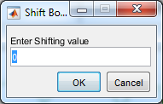

Figure : Shift bottom window

## Copy the bottom line from one channel to others

Remember that the bottom line, the bad transmits flags, and the regions are defined separately for each frequency channel in a file (Figure 24). To copy over a bottom line to another channel, get in Normal Mode (shortcut 0), right-click on the bottom line, select Copy to other channels and choose which channel(s) to copy this bottom line to. If these channels already have a bottom line, it will be overwritten.

## Saving/loading the bottom line

ESP3 offers two different methods to save bottom, bad transmit or regions edits. By default, use the simpler XML method. Note that bottom line and bad transmits for all channels where they exist are always saved together.

### XML

The XML method saves the bottom and bad transmits of all channels into a XML file for each data file. There is only one XML file possible for each data file so saving repeatedly to XML simply overwrites the values previously saved.

In the Menu, under Bottom/Regions, then XML, select Save Bottom to xml to save the bottom line and the bad transmits of all channels. If you also have regions set and wish to save them too, you can select Save Bottom/Regions to xml instead – regions are saved in a separate XML file.

You can also load the latest bottom line and bad transmits saved, by selecting Load Bottom from xml. This will overwrite the current bottom line and bad transmits, using the latest saved version. If you wish to load previously saved regions at the same time, you can select Load Bottom/Regions from xml.

### Database

The database method allows saving several versions of the bottom line and bad transmits, which is useful for archiving. In the Menu, under Bottom/Regions, then DB, select Save Bottom to db to save the bottom line and bad transmits into a database entry. Then, go to Load Bottom and/or Regions from db to add a comment to that version you just saved (Figure 33).

Right-click on an entry in this table to load or delete this entry.

Again, if you wish to save regions at the same time, you can do so by selecting Save Bottom/Regions to db.

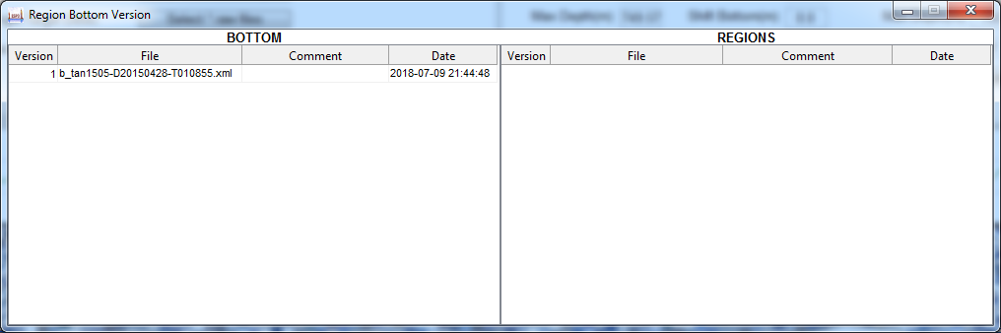

Figure : Menu, Bottom/Regions, DB, Load Bottom and/or Regions from db

# Bad transmits

## Display of bad transmit flags

Bad transmit flags show as vertical, half-transparent, red lines on the Echogram (Figure 23), but only if the option Display Bad transmits is selected in the Display section of the Menu (shortcut T). The total percentage of bad transmits in the data is displayed in the bottom-left part of the Bad Pings/Samples Detect tab in the Algorithms Panel (Figure 34).

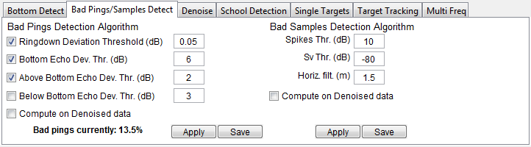

Figure : “Bad Pings/Samples Detect” tab in the Algorithms Panel, used to access the “Bad Pings Detection algorithm” and the “Bad Samples Detection Algorithm”. All parameters shown are default settings. On the bottom-left, this panel also shows the current percentage of pings flagged as bad.

## Automatic detection of bad transmits

ESP3 offers an algorithm for the automatic detection of bad transmits, the parameters of which are accessible in the Bad Pings Detection Algorithm section of the Bad Pings/Samples Detect tab in the Algorithms Panel (Figure 34).

The Bad Pings Detection algorithm is made up of five independent sub-algorithms whose results are combined. The first of them – the “undefined bottom-line analysis”, which flag pings that do not have a valid bottom detect – is always applied and does not offer any controllable parameter. The four others are optional and are controlled by one parameter each. The four first lines in the Bad Pings Detection Algorithm section correspond to these four sub-algorithms – they include a check box to switch on or switch off the corresponding algorithm and a value field for its parameter. Those four sub-algorithms are, in order:

* The ringdown analysis (ON by default), which will flag pings whose ringdown level deviates too much from the local average level, as controlled by the “**Ringdown Deviation Threshold**” parameter (Ringdown\_std), which has a default value of 0.05 dB.
* The bottom-echo backscatter analysis (ON by default), which will flag pings whose bottom echo deviates too much from the average level, as controlled by the “**Bottom Echo Deviation Threshold**” parameter (BS\_std), which has a default value of 6 dB.
* The above-bottom-echo backscatter analysis (ON by default), which will flag pings for whom the level above the bottom echo spikes compared to surrounding pings, as controlled by the “**Above-Bottom-Echo Deviation Threshold**” parameter (thr\_spikes\_Above), which has a default value of 3 dB.
* The below-bottom-echo backscatter analysis (OFF by default), which will flag pings for whom the level between the bottom echo and the first multiple spikes compared to surrounding pings, as controlled by the “**Below-Bottom-Echo Deviation Threshold**” parameter (thr\_spikes\_Below), which has a default value of 3 dB. Note that this sub-algorithm is very sensitive if there are few data below the bottom echo.

Below these, the **“Compute on Denoised data”** parameter (denoised) controls whether the algorithm is applied to the normal data or after denoising.

The algorithm is fully described in Appendix.

As with the bottom detection algorithms, the bad transmit detection algorithm can be applied from three different places:

* Click on the Apply button in the same tab as the parameters in the Algorithms Panel (Figure 34) to apply the algorithm to the entire file/layer currently loaded and displayed on the echogram.
* Go to the Processing tab in the Control Panel (Figure 28), check the appropriate check box (“Bad Pings Detection”) and choose the appropriate button to apply the algorithm either to the file/layer currently displayed (“Apply to current layer”), to all files/layers that have been loaded (“Apply to all loaded layers”), or to a set of files that have not been loaded yet (“Select \*.raw files”).
* Create a selection box to the part of echogram where the algorithm is to be applied, then, while in Normal mode (shortcut 0), right-click on the selection box and choose Apply Algorithm…, then Bad Pings Detection (Figure 29).

The first approach is useful to test the results of the algorithm with different settings, making use of the keyboards shortcuts Ctrl+Z and Ctrl+Y to respectively undo and re-do an application of the algorithm, until appropriate settings have been found. The second approach is then useful to apply the algorithm with these final settings to an entire survey (possibly along with other algorithms).

## Manual edition of bad transmits

After automatic detection, one can get into Bad Transmit mode (shortcut 2) to edit the results manually:

* Left-click: Flag a ping as bad transmit.
* Left-click, drag and release: Flag series of pings as bad transmits.
* Right-click: Remove bad transmit flag.
* Right-click, drag and release: Remove bad transmit flag for series of pings.

You can use the keyboards shortcuts Ctrl+Z and Ctrl+Y to undo and re-do, respectively, any of these changes.

## Copy bad transmit flags from one channel to others

Remember that the bottom line, the bad transmits flags, and the regions are defined separately for each frequency channel in a file (Figure 24). To copy over bad transmits to another channel, get in Normal Mode (shortcut 0), right-click anywhere on the echogram, select Bad Transmits and choose which channel(s) to copy the bad transmits flags to. If these channels already have bad transmits, they will be overwritten.

## Saving/loading the bad transmits flags

Bad transmits flags are always saved at the same time as the bottom line, so the exact same options discussed previously apply.

### XML

The XML method saves the bottom and bad transmits of all channels into a XML file for each data file. There is only one XML file possible for each data file so saving repeatedly to XML simply overwrites the values previously saved.

In the Menu, under Bottom/Regions, then XML, select Save Bottom to xml to save the bottom line and the bad transmits of all channels. If you also have regions set and wish to save them too, you can select Save Bottom/Regions to xml instead – regions are saved in a separate XML file.

You can also load the latest bottom line and bad transmits saved, by selecting Load Bottom from xml. This will overwrite the current bottom line and bad transmits, using the latest saved version. If you wish to load previously saved regions at the same time, you can select Load Bottom/Regions from xml.

### Database

The database method allows saving several versions of the bottom line and bad transmits, which is useful for archiving. In the Menu, under Bottom/Regions, then DB, select Save Bottom to db to save the bottom line and bad transmits into a database entry. Then, go to Load Bottom and/or Regions from db to add a comment to that version you just saved (Figure 33).

Right-click on an entry in this table to load or delete this entry.

Again, if you wish to save regions at the same time, you can do so by selecting Save Bottom/Regions to db.

# Regions

## Display of regions

Regions show as areas in green, red, yellow, or brown over the Echogram (Figure 35), labelled with their Tag followed by their ID between parentheses, but only if the option Display Regions is selected in the Display section of the Menu (shortcut R). When the display option is deselected, the regions boundaries and labels will still show on the echogram but it is not possible to interact with the regions (Figure 36).

The tab Region List in the Control Panel lists all regions created on the current frequency channel, with their parameters (Figure 35).

Note that regions, like the bottom line and bad transmit flags, are defined separately for each frequency channel.

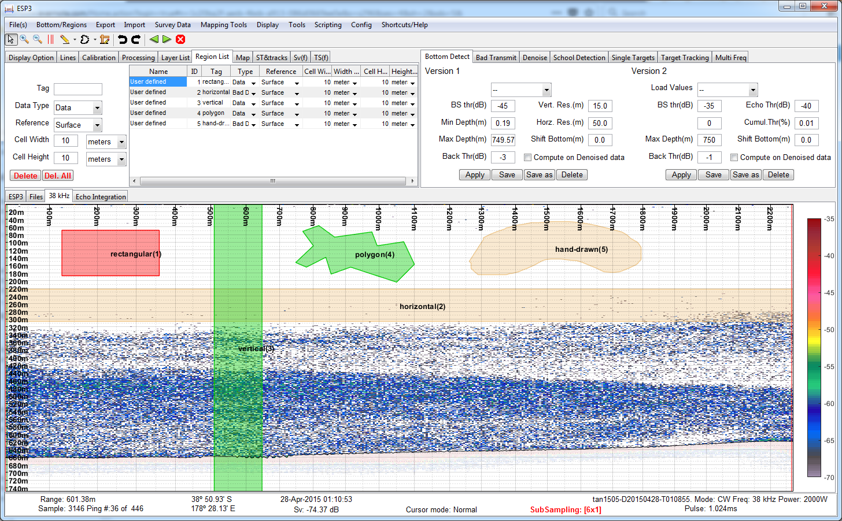

Figure : The five possible shapes for user-defined regions: Rectangular (1), Horizontal (2), Vertical (3), Polygon (4), and Hand Drawn (5). Regions with type “Data” are in green if inactive, red if active. Regions of type “Bad Data” are yellow if inactive, brown if active. Note the Regions list tab is open in the Control Panel to list these regions and allow editing them.

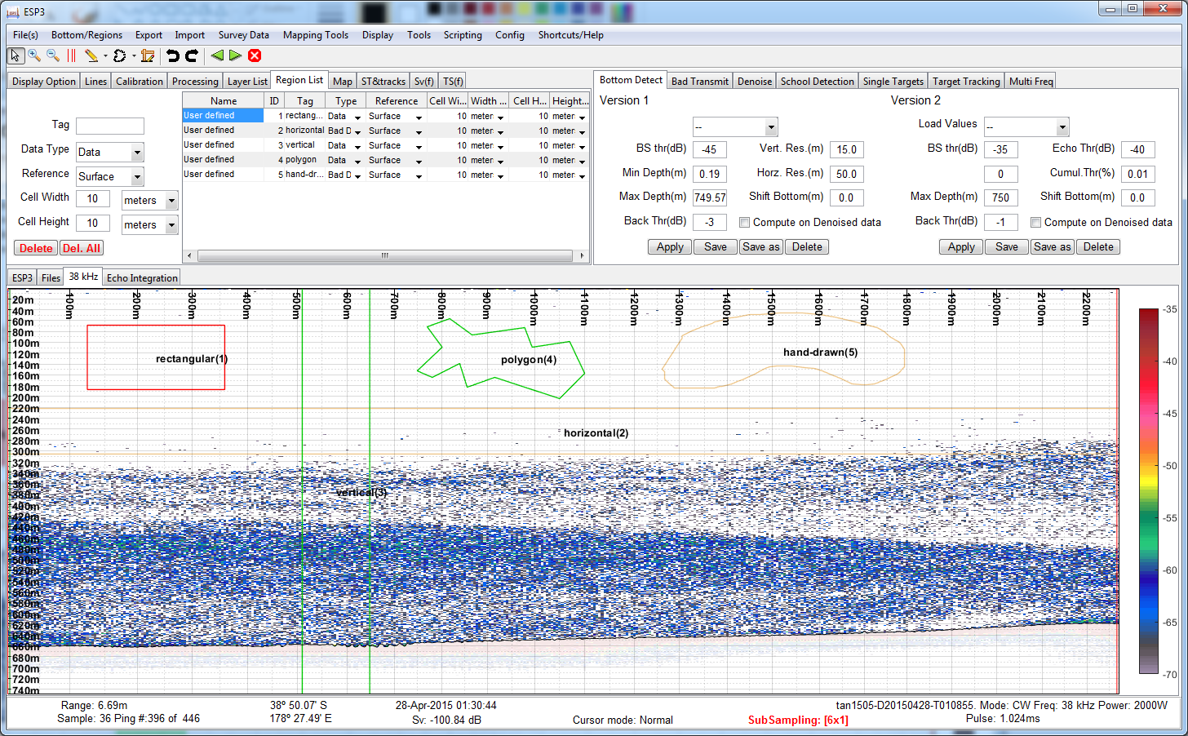

Figure : Same data and regions as previous figure, but with “Display Regions” unselected

## Active vs inactive regions

Some actions in ESP3 are only applicable to regions currently active.

A region of type “Data” shows in green when inactive, or red if active (Figure 35). A region of type “Bad Data” shows in brown when inactive, or yellow if active.

To activate a region from the echogram, simply click on it while in Normal Mode (shortcut 0) or Create Region mode (shortcut 4). Hold the Ctrl key and left-click on each region to make several regions active.

You can also click on the row corresponding to the region of interest in the Region List tab of the Control Panel, or hold the Ctrl key and left click several rows to activate several regions.

Note that a newly created region is automatically activated.

## Region parameters

### Name: “User defined”, “WC”, or “School”

There are three methods to create regions, and the Name parameter refers to which method was used to create the region. Accordingly, this parameter cannot be changed. Refer to the following sections for details about each of these methods of creation.

### ID

Each region is given an incrementing number as an ID at creation. This ID is displayed in parentheses on the corresponding region in the Echogram. This parameter can be changed in the Region List tab of the Control Panel.

### Tag

A region tag is a string of characters used to label all regions that need to be integrated together. Species names or acronyms are typically used as tags. The Tag is displayed as a label on the corresponding region in the Echogram. This parameter can be changed in the Region List tab of the Control Panel.

### Type: “Data” or “Bad Data”

While regions were designed to identify the areas of interest for echo integration, it is also possible to use them to flag areas to exclude from the echo integration. A region with type “Bad Data” will be excluded from echo integration calculations just like samples under the bottom line or samples from pings flagged as bad transmits. This parameter can be changed in the Region List tab of the Control Panel.

### Cell Width and Height

While one may wish to perform the echo integration on all samples within the entire region – that is, to return a single backscattering coefficient for the region – ESP3 allows a finer level of detail by binning samples within cells of set width (in number of pings, seconds, or meters) and set height (in number of samples, or meters). The region cell is thus the actual unit area of interest during integration, and echo integration of a region is simply the sum of the results of the echo integration on its constituent cells.

The four parameters Cell Width, Cell Width Unit, Cell Height and Cell Height Unit can be changed in the Region List tab of the Control Panel.

### Reference: “Surface”, “Bottom”, or “Line”

Given the binning of a region in cells, as discussed above, it is thus necessary to define the vertical reference for the vertical bins. Usual references will be the surface (Depth = 0 m) or the bottom line. ESP3 also offers tools to define other lines – using the Lines tab of the Control Panel – to be used as reference lines. This can be used to integrate data using a trawl path as a vertical reference, for instance.

## User-defined regions

User-defined regions are regions created manually by interacting with the Echogram using the “Create Region” mode (shortcut 4). The down arrow next to the “Create Region” mode icon in the Tools bar allows access to the five different shapes of user-defined regions (Figure 37).

Even though all parameters of a region can be modified after its creation through the Region List tab, you can preset the desired parameters of a region to be created in the left-hand part of the Region List tab of the Control Panel (Figure 38). This is useful in case you need to create multiple regions with the same parameters.

The five shapes of user-defined regions are shown on Figure 35. They are:

* Rectangular: rectangular region on the echogram, defined by a first and last ping, and a minimum and maximum depth. Left-click to define a corner, hold down the button and drag, and release to define the opposite corner.
* Horizontal: as rectangular region except the ping bounds are automatically set to the minimum and maximum values in the file, thus restricting the region drawing to a horizontal section of the histogram. Left-click to define a first depth bound, hold down the button and drag, and release to define the other depth bound.
* Vertical: as a rectangular region except the depth bounds are automatically set to the minimum and maximum values in the file, thus restricting the region drawing to a vertical section of the histogram. Left-click to define a first ping bound, hold down the button and drag, and release to define the other ping bound.
* Polygon: polygonal region defined by its vertices. Left-click to define each vertex and complete the drawing with a double left-click or right-click.
* Hand Drawn: draw a region of any shape on the echogram. Left-click to start drawing, hold the button and drag as desired, and release the button to complete the drawing.

You can use the keyboards shortcuts Ctrl+Z and Ctrl+Y to undo and re-do, respectively, any of these actions.

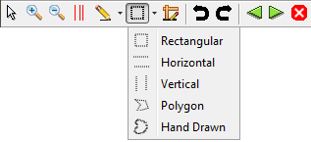

Figure : The five possible shapes for user-defined regions are accessible from the Tools bar

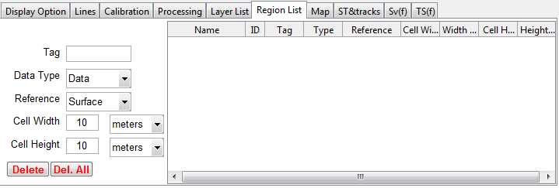

Figure : The "Region list" tab in the Control Panel has two parts: on the left, inform the parameters of new user-defined regions before creating them. On the right is the list of regions created.

## Water-Column (WC) regions

WC regions are regions spanning the entire set of pings in the Echogram, only bounded to a range of depths or height above the seabed. They are generated by going to the Menu, choosing Tools, then Regions Tools, then Create WC Region. A window then appears where parameters can be set (Figure 39).

Since a WC region spans the entire set of pings, it can be thought as similar to a user-defined region of Vertical shape, with the only difference being that the depth bounds in a WC region are informed numerically, instead of “by hand”. However, this comparison is only valid when using the Surface as a reference line. When referenced to the bottom line, WC regions are markedly different.

When a WC region is defined with the bottom line as the reference line (Figure 40), the region thus created will be shaped following the bottom line (Figure 41). This difference is the result of the difference in purpose between user-defined regions and WC regions. Where user-defined regions are created to target schools and other targets of interest, WC regions are created to run echo integration on the entire file, at set depths of interest, or set distance from the bottom.

You can use the keyboards shortcuts Ctrl+Z and Ctrl+Y to undo and re-do, respectively, the creation of a WC region.

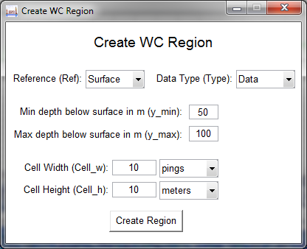

Figure : "Create WC Region" tool with Surface as reference

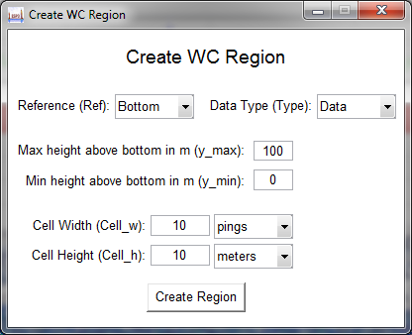

Figure : "Create WC Region" tool with Bottom as reference

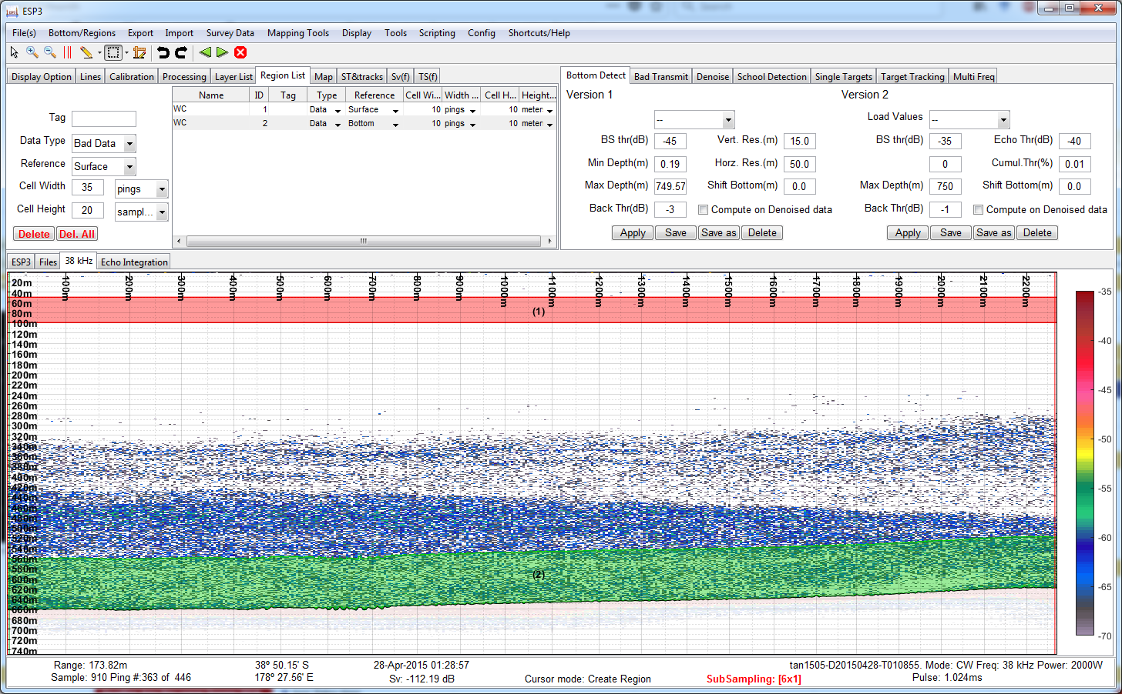

Figure : A surface-referenced WC region between 50 m and 100 m depth below surface (1), and a bottom-referenced WC region between 0 m and 100 m height above the bottom line (2)

## School regions (school detection algorithm)

ESP3 offers an algorithm for the automatic detection of schools, which results in automatically defined “School” regions. The algorithm parameters are accessible through the School Detection tab in the Algorithms Panel (Figure 42). It has eight parameters:

* Can. Min. Len(m): XXX. Default 10
* Can. Min. Hgth(m): XXX. Default 10
* Tot. Min. Len(m): XXX. Default 50
* Tot. Min. Hgth(m): XXX. Default 20
* Max. horz. link(m): XXX. Default 5
* Max. vert. link(m): XXX. Default 5
* Min. sple number: XXX. Default 100
* Sv Thr.(dB): XXX. Default -65

Compute on denoised data XXX

Trees? XXX

You can use the keyboards shortcuts Ctrl+Z and Ctrl+Y to undo and re-do, respectively, the creation of a School region.

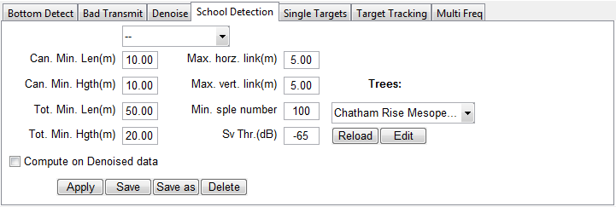

Figure : “School detection” tab in the Algorithms Panel, with default settings.

## Interacting with regions

As usual, you can use the keyboards shortcuts Ctrl+Z and Ctrl+Y to undo and re-do, respectively, any of the following actions.

### Deleting a region

To delete one or several regions, make it/them active and press the Delete key. From the Region List tab in the Control Panel, you can also right-click and select Delete region(s) or press the Delete button in the tab.

To delete all regions whether active or inactive, click on the Del. All button in the Region List tab in the Control Panel.

### Moving a region

Any region can be moved around by getting into Normal Mode (shortcut 0) and left-clicking on the region and dragging.

### Merging several regions

Overlapping regions can be merged by getting in Create Region mode (shortcut 4), right-clicking on any region and choose Region, then Merge Overlapping Regions.

The other option Merge Overlapping Regions (per Tag) is also available to limit the merging to regions that are both overlapping and sharing a same Tag.

### Modifying the boundaries of a region

Once created, the relative boundaries of a region cannot be modified (except for moving the entire region as described earlier). However, a region can be “grown” by creating a new region where the extension is needed in such way as it overlaps with the original and merge those two regions. Similarly, a region can be “eroded” by creating a “Bad Data” region where the erosion is needed and merge those two regions.

### Modifying the parameters of a region

As described previously in the section about region parameters, all parameters of a region (at the exception of its name) can be modified in the Region List tab of the Control Panel.

### Copying a region to other frequencies

Regions are only created for the current frequency channel. However, they can be copied over to the other channels by right-clicking on the active region and choosing Region, then Copy to other frequencies.

## Saving/loading regions

### XML

The XML method saves the regions of all channels into a XML file for each data file. Saving repeatedly to XML simply overwrites the regions previously saved. When spanning several files, regions will be split when saved, then re-merged at loading.

In the Menu, under Bottom/Regions, then XML, select Save Regions to xml to save the regions of all channels. If you also have bottom line and bad transmits defined and wish to save them too, you can select Save Bottom/Regions to xml instead.

You can also load the latest regions saved, by selecting Load Regions from xml. This will overwrite the current regions, using the latest saved version. If you wish to load previously saved bottom line and bad transmits at the same time, you can select Load Bottom/Regions from xml.

### Database

The database method allows saving several versions of the regions, which is useful for archiving. In the Menu, under Bottom/Regions, then DB, select Save Regions to db to save the regions into a database entry. Then, go to Load Bottom and/or Regions from db to add a comment to that version you just saved (Figure 33).

Right-click on an entry in this table to load or delete this entry.

Again, if you wish to save bottom line and bad transmits at the same time, you can do so by selecting Save Bottom/Regions to db.

# Handling multiple files

## Survey and layers

A typical acoustic survey results in the recording of several raw data files, acquired for various purposes, areas, stations, repeats, etc., which implies a need to identify files and differentiate between data records. In addition, it is common that data recorded for a specific purpose do not exactly span a single, entire file. For example, a long individual acoustic transect may span several consecutive files, or a single file may contain several short transects requiring separate processing.

To manage this, ESP3 provides a system of **metadata** that makes two assumptions:

* All files within a same folder were acquired as part of the same **survey** and are meant to be processed together. Data in different folders are considered separate surveys.
* Individual files are not the unit source of data, but instead any consecutive files or sections of files acquired for the same purpose, as identified by their common metadata. These are termed **layers**.

## Metadata attributes

A survey is identified by two metadata attributes, which thus apply to all layers within the survey:

* Survey name: A free-text attribute normally used for the full name of survey, including for example year, location, type of survey or target species.
* Voyage: A free-text attribute normally used for the voyage code.

A layer in a given survey is identified by four metadata attributes:

* Snapshot: A numerical attribute (integer) normally used to identify the survey repeat to which the layer belongs.
* Type: A text attribute following a controlled vocabulary, normally used to identify the activity or purpose behind the acquisition of a layer. The controlled vocabulary is defined in the file types.xml located in the config folder of the ESP3 application (normally, C:\Program Files\ESP3\_ver\_X.X.X\config). It is thus editable by modifying the XML file. The default vocabulary is:
  + “Acoustic": General purpose type, used for acquisition of an acoustic transect.
  + “Whales": Whales Observations.
  + “RMT": RMT Trawl.
  + “Trawl": Acoustic file recorded during trawling.
  + “Steam": Acoustic file recorded while steaming between stations.
  + “Mooring": Mooring deployment.
  + “Calibration": Calibration layer.
  + “Deployment": Instrument deployment.
* Stratum: A free-text attribute normally used to identify the geographical stratum where the layer was acquired.
* Transect: A numerical attribute (integer) normally used to identify a layer within a set of layers defined by some snapshot/stratum/type combination.

## Editing metadata from the echogram

The direct way to enter or edit existing survey or layer metadata is to right-click on the echogram, select Survey Data, then either:

* Edit Voyage Info to edit the metadata for a survey (Figure 43 left),
* Edit/Add Survey Data for this file to edit the metadata for the file which data was clicked on (Figure 43 right), or
* Edit/Add Survey Data to edit the metadata for a layer which data was clicked on (Figure 43 right).

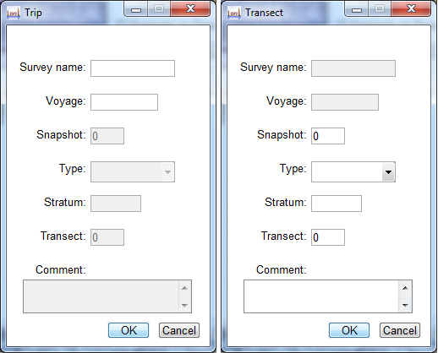

Figure : The pop-up windows opening to edit survey metadata (left) or file metadata (right)

## Logbook

The logbook is a display of all files/layers within a given folder (survey) and their associated metadata. Layers metadata can be edited directly in the logbook.

**To open the logbook**, go to the Menu, select Survey Data, then Edit/Display logbook (shortcut L).

* If a file is already loaded in ESP3, the software automatically opens the logbook to which this file is part of.
* If no file is loaded, ESP3 will prompt you for the logbook file you wish to open.
* If a file is already loaded in ESP3 and you wish to open another logbook than the one corresponding to the loaded file, use the keyboard shortcut Shift + L.

In all cases, the logbook appears in the main panel, as a new tab alongside the Echogram tab (Figure 44).

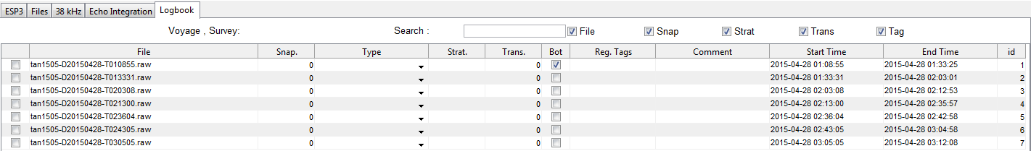

Figure : A logbook in ESP3 open as a separate tab in the Main Panel, listing the files/layers in the survey and their metadata

Besides the layers metadata, the logbook lists the following information:

* File: The file name. This attribute cannot be edited within the logbook.
* Bot: a check box indicating if a bottom line has been saved for the corresponding file. This attribute cannot be edited within the logbook.
* Reg. Tags: a list of the tags of regions saved in the corresponding file. This attribute cannot be edited within the logbook.
* Comment: Free-text field.
* Start Time: Time of first ping recorded in the file. This attribute cannot be edited within the logbook.
* End Time: Time of last ping recorded in the file. This attribute cannot be edited within the logbook.
* id: Numerical identifier of the file in the logbook. This attribute cannot be edited within the logbook.

## Layer list

The Layer List tab in the Control Panel shows the layers currently loaded in ESP3 (Figure 45). Selecting a layer automatically displays the corresponding data in the echogram

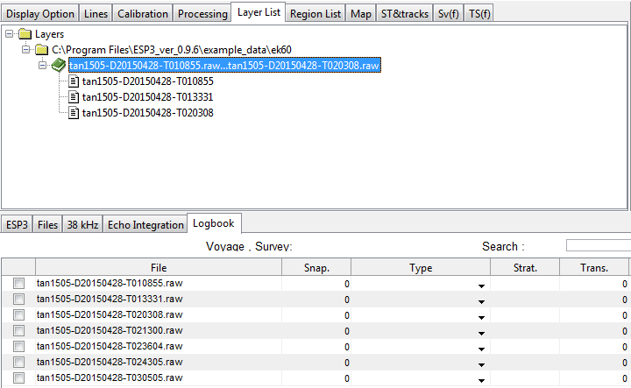

Figure : Layer List tab in the Control Panel, after loading the three first files of the example dataset. Since those files have the same (empty) metadata (as informed by the logbook), they were combined into a single layer (highlighted)

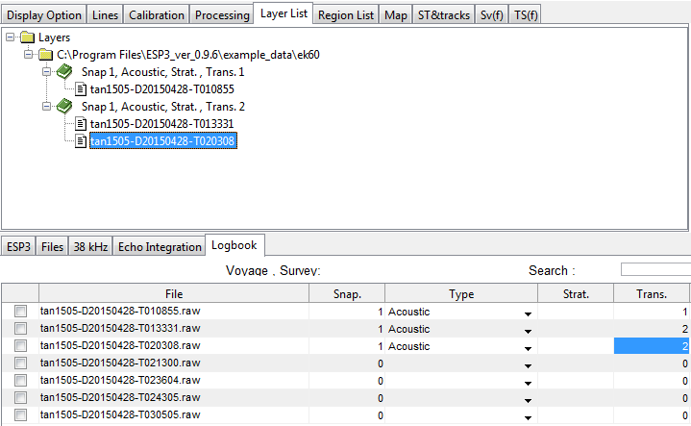

Figure : Same as above but with metadata informed for the three files. Since the second and third files have the same metadata, they were combined into a single layer, separate from the first file given its unique metadata

## Display of files and layers in the echogram

The start of a layer is displayed by a vertical green line, the end of a layer by a vertical red line, and the end of a file (and start of a new one) by a vertical black line (Figure 47). The latest is only true if the Display File Line option in the Display section of the Menu is selected.

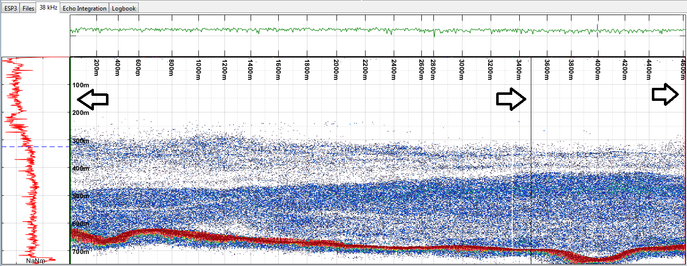

Figure : The start (resp. end) of a layer is displayed by a vertical green (resp. red) line, as indicated here by the leftmost (resp. rightmost) arrow. The end of a file and start of a new one is displayed as a vertical black line as indicated by the middle arrow. This echogram is that of two files making up a single layer.

## Splitting one layer into two

To split a layer into two, right-click on the echogram where you wish the split to happen and select Survey Data, then Split Transect Here. ESP3 will then prompt you to fill metadata for the first layer (before the split), and then the second layer (after the split) (Figure 48). Enter different metadata to ensure you create two layers.

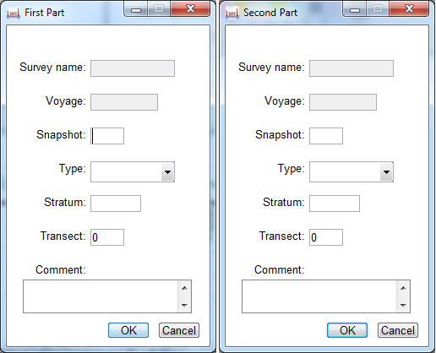

Figure : Popup windows prompting for metadata for the two new layers after a transect split

ESP3 acknowledges the split into two layers by displaying the red and green vertical lines that mark the end and start of a layer, respectively (Figure 49). Also, in the logbook, the same file will now appear on two separate lines with correspondingly different metadata (Figure 50).

To split a file into more than two layers, simply repeat the process as often as necessary.

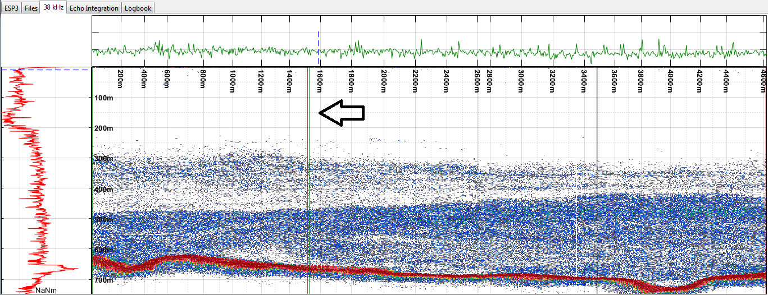

Figure : ESP3 acknowledges the split into two layers by displaying the red and green vertical lines that mark the end and start of a layer, respectively

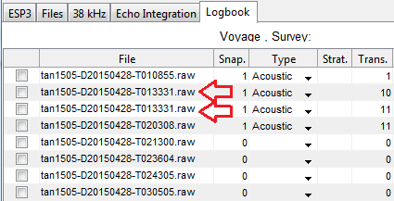

Figure : Logbook with a file split into two layers

# Basic echo-integration

## Echo-integration of a region

To integrate the data within a region in 2D bins, activate the appropriate Region in the Echogram, right-click on the Region, select Region, then Display, and then Region Sv (Figure 51). The data within the region, echo-integrated in 2D bins of size defined by the region parameters (cell width and height and their respective units), will appear as a separate window (Figure 52). Averages across depth/range and across pings/distance/time are displayed on the left-hand side and on the bottom, respectively. The range of the color scale in this window is linked to the one for the main display in the main window and can thus be modified by changing the C-Max and C-Min parameters in the Display Option tab of the Control Panel.

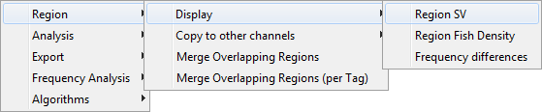

Figure : Right-click on a region to access the tool to display the 2D-binned Sv for the data within the region

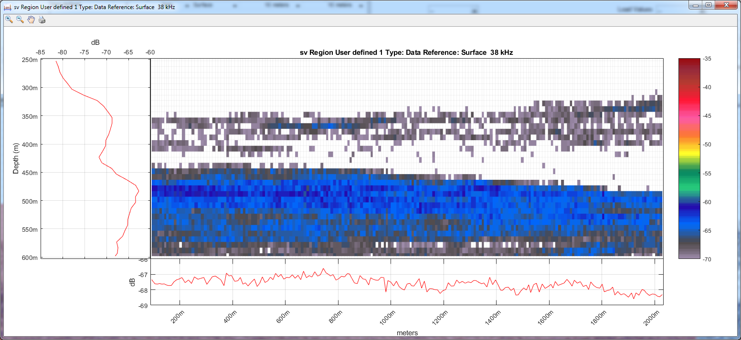

Figure : The data within a region, integrated in 2D bins

To export the results of this integration, right-click on the Region, select Export, then Export integrated region to .xlsx.

The output is composed of several spreadsheets within a single file .xlsx file. The first sheet contains general information about the region:

* The metadata about the survey where the region is found (SurveyName and Voyage).
* The metadata about the transect(s) where the region is found (Snapshot, Stratum, Type, Transect).
* Some basic identifying metadata about the region itself (Tag, ID).
* A few general statistics and measures relative to the region: Lat, Long, Time, Bottom\_mean\_depth, Length, Height, Mean\_depth, MaxDepth, MinDepth, StartTime, EndTime, Perimeter, Area, Roundness.
* Average and standard deviation of Sv per cell within the region at all frequencies available: Sv\_18kHz, Delta\_Sv\_18kHz, Sv\_38kHz, Delta\_Sv\_38kHz, etc.

Each following spreadsheet in the file shows the results of the echo-integration of the region’s data for each frequency channel. In these, each row corresponds to one cell of the region, and each column corresponds to one variable value for the corresponding cell. Cells are listed as if read in columns (“Vert\_Slice\_Idx”) starting with leftmost one.

The variables are:

* nb\_samples: number of valid samples in the cell.
* eint: $\sum_{∈cell}{s_{v}}dr {(m}^{2}m^{-2})$ where $dr$ is the sample thickness.
* Sv\_dB\_std: $Std\left(S_{v}\right)\left(dB\right)$.
* Vert\_Slice\_Idx: Vertical slice index.
* Horz\_Slice\_Idx: Horizontal slice index.
* Ping\_S: first ping number in cell.
* Ping\_E: last ping number in cell.
* Nb\_good\_pings: number of valid pings in cell.
* Sample\_S: first sample number in cell.
* Sample\_E: last sample number in cell.
* Layer\_depth\_min: minimum depth of cell (m).
* Layer\_depth\_max: maximum depth of cell (m).
* Depth\_mean: mean depth of cell (m).
* Range\_ref\_min: minimum range of cell according to region reference (m).
* Range\_ref\_max: maximum range of cell according to region reference (m).
* Thickness\_tot: total thickness of cell (m).
* Thickness\_mean: $Thickness_{mean}=\frac{nb_{samples}}{nb_{good_pings}}dr$
* Dist\_S: start of cell in along-track distance (m).
* Dist\_E: end of cell in along-track distance (m).
* Time\_S: start of cell in time (format dd/mm/yyyy HH:MM:SS.FFF).
* Time\_E: end of cell in time (format dd/mm/yyyy HH:MM:SS.FFF).
* Lat\_S: start of cell in latitude (decimal degrees).
* Lon\_S: end of cell in latitude (decimal degrees).
* Lat\_E: start of cell in longitude (decimal degrees).
* Lon\_E: end of cell in longitude (decimal degrees).
* Sv\_mean\_lin: $s_{v}(m^{-1})$
* PRC:percentage of cell being using valid samples $PRC= \frac{nb_{samples}}{nb_{good_pings}×Thickness_{tot}}dr$
* ABC: Area Backscattering Coefficient $ABC=s_{v}×Thickness_{mean} (m^{2}m^{-2})$
* NASC: Nautical area scattering coefficient $NASC=4π×{1852}^{2}× ABC(m^{2}n{mi}^{-2})$

## Echo-integration of a transect

To integrate the data from the entire transect in 2D bins, use to the Echo Integration tab in the Main Panel (Figure 53).

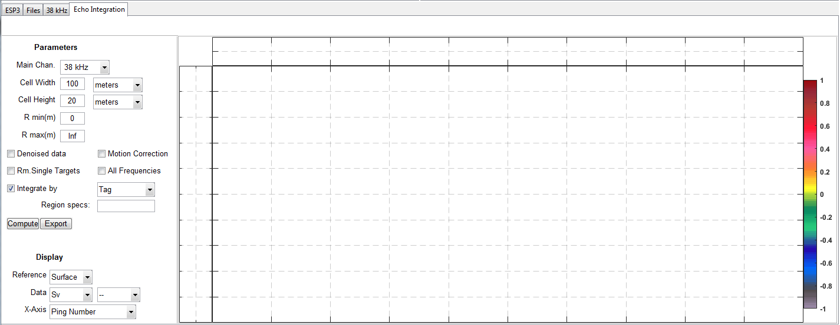

Figure : Echo-integration tab in the Main Panel

The left-hand-side of the tab allows a flexible control of the echo-integration process:

* First, define the frequency channel of interest (Main Chan.), the binning parameters (Cell Width and Cell Height and their units), and the minimum and maximum range of interest if applicable (R min(m) and R max(m)). Data outside of this range will simply be discarded from calculations.
* Then, define the data to be integrated by checking the appropriate boxes to use data after denoising, or motion correction, or after removal of single targets, or a combination of these.
* Next, define whether to integrate all data in the transect (leaving Integrate by box unchecked) or only data within regions of interest (check Integrate by box and provide information on the region(s) to integrate in Region specs).
* Finally, press the Compute button to perform the echo integration calculation (Figure 54).

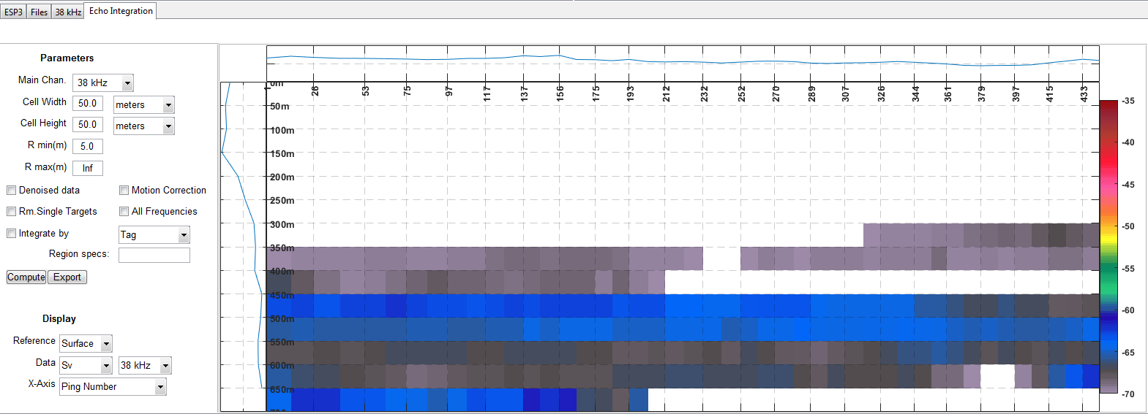

Figure : Example of echo integration of a transect, using the first example file and integrating the entire transect in bins of 50 m high and 50 m wide, excluding data in the top 5 m.

ESP3 automatically echo-integrates the data both with surface and bottom as the horizontal reference (if the bottom line has been defined). It is then possible to switch the display from one to another using the corresponding drop-down menu in the Display section. It is also possible to display other results than integrated Sv, other frequencies if the echo integration was computed with the All Frequencies box checked, or with re-projecting the data on a different X axis unit.

Click the Export button to export the results to a file in the .csv format. The exported results will be in the same format as for regions integrated in 2D bins, as discussed previously.

# Survey processing with the scripting module

## Introduction to scripts

The primary purpose of ESP3 is to produce combined results of the echo-integration of many acoustic data files for the estimation of fish biomass in a survey. This is done through the *scripting module*, which allows the user to run batch processing on several transects, with set algorithms and set parameters of his or her choice, all described on a text file following a predefined format, coded in XML, and called *script* (Figure 55).

In summary, a script typically contains:

* The ESP3 **general parameters** (such as sound speed, absorption coefficient, or echo-integration parameters);
* The **algorithms** to be applied and their parameters;
* The version of the bottom detect or bad transmits flags to use;
* The **calibration values**;
* **The transects to be processed** (identified by their metadata attributes); and
* The **regions** within which data is to be echo-integrated.

In survey processing, ESP3 echo-integrates data at the fundamental level of a vertical slice of transect, defined by the vertical\_slice\_size and vertical\_slice\_units parameters.

When a script is run, ESP3 uses the information in the file to:

* Load the desired data (transects, bottom line, bad flag transmits, regions, etc.);
* Set the desired parameters;
* Run the desired algorithms in the order they are listed;
* Performs an echo-integration of all data included in the desired regions at the exclusion of bad data (under the bottom line, flagged as bad transmit, bad data region, or out of desired depth bounds), for each *vertical slice* of each transect;
* Combine the results per vertical slice into results per transect, and then into results per stratum; and
* Export these results in a spreadsheet file (.xlsx).

Results will be generated at the three levels mentioned: per transect slice, per transect, and per stratum.

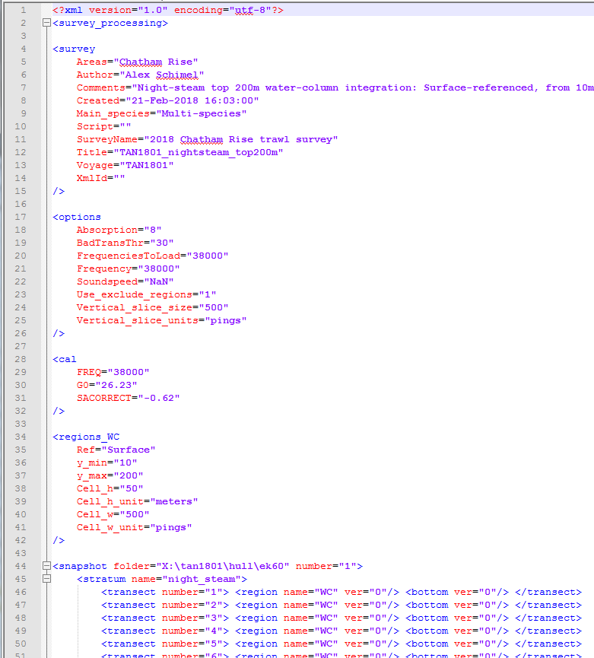

Figure : Example of an actual ESP3 script used for processing acoustic data acquired as part of a trawl survey

## Folder for scripts and survey processing results

The folder for the scripts and the folder for the results from the batch processing they operate must be specified. Go to the Menu, select Config, then Path. The Path Options window appears, indicating the current Scripts and Results folders, and allowing you to change them if needed (Figure 56).

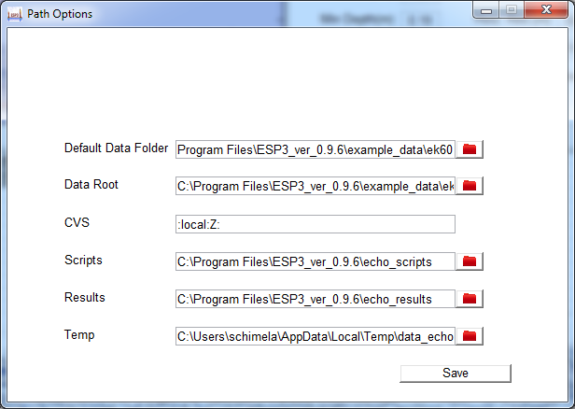

Figure : The Path Options window

## The scripting module

Go to the Menu, and select Scripting, then XML Scripts to open the scripting module (Figure 57). The scripting module lists all scripts available in the script folder with basic information for each. Right-click on a row to interact with a script (Figure 58). Options available are:

* Run: Run the script.
* Check Script: Check that the script format is valid. Note, this does not ensure that the script is error-free (for example, it does not check if the transects metadata are accurate).
* Reload Figure: This reloads the module. Use this when you’ve added a text file to the script folder (so as the module detects it) or if you’ve modified the script metadata.
* Edit: Opens the script externally, to allow modifying it.

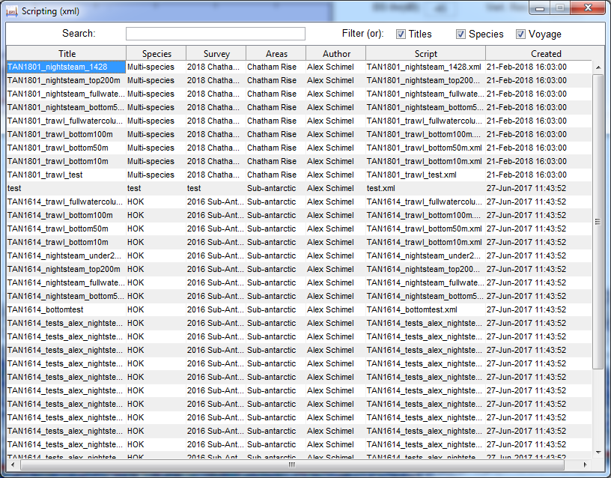

Figure : The scripting module

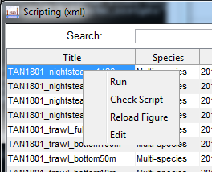

Figure : Right-click on a script to edit it, check its validity, or run it

## Script format

### Root organization

An ESP3 script is organized as follows (Figure 59):

* The file starts with the XML prolog <?xml version="1.0" encoding="UTF-8"?>
* The root element is called <survey\_processing>
* This root element has six child elements:
  + <survey ... /> is a self-closing tag with attributes providing information (metadata) about this script and the data it processes.
  + <options ... /> is a self-closing tag with attributes defining ESP3 parameters.
  + <cal ... /> is a self-closing tag with attributes defining the calibration parameters for one frequency. There can be several of these tags – one for each frequency.
  + <regions\_WC ... /> is a self-closing tag with attributes defining one WC region. This element is optional.
  + <algos> is a regular element whose contents are elements for each algorithm to be applied.
  + <snapshot ...> is a regular element whose contents will list the transects to be processed.

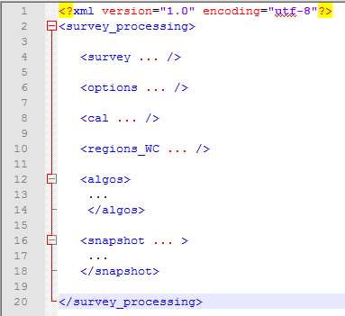

Figure : The general organization of an ESP3 script

### The <survey ... /> element

The <survey ... /> element is a self-closing tag with attributes providing information (metadata) about this script and the data it processes.

The attributes available are (Figure 60):

* Areas: Geographical area where survey took place.
* Author: Script author.
* Comments: Free-text field for comments, typically summarizing the batch processing being applied.
* Created: Date of creation for script, in the “dd-mmm-yyyy HH:MM:SS” format.
* Main\_species: tag(s) for the species being targeted.
* Script: file where the script is saved
* SurveyName: Full name of the survey.
* Title: title given to the script (describing the processing)
* Voyage: name of the associated voyage/trip/mission
* XmlId: not used at the moment.

Although none of this information affects the results of the batch processing, it is strongly recommended to be completed carefully to avoid confusion between the many scripts that are typically generated for any survey (see Figure 57 for example).

If an attribute is not specified, ESP3 will use empty text as the default value for it.

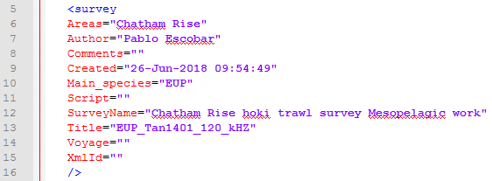

Figure : An example of complete <survey ... /> element in an ESP3 script

### The <options ... /> element

The <options ... /> element is a self-closing tag with attributes defining the ESP3 parameters for batch processing.

The attributes of this element and default values are (Figure 61):

* Absorption: Absorption to be used for the survey (db/km). Default: “NaN”: will use file absorption. If multiple frequencies are loaded, specify absorption for each frequencies separated by “;”.
* BadTransThr: Threshold on Bad Transmits percentage. Transect with more than BadTransThr% of bad transmits will be removed from further analysis. Default: “100” (keeps all transects).
* CopyBottomFromFrequency: Specified as one of the loaded frequencies. If not left to “0”, it will copy from the bottom from the specified frequency to all other ones. Default: “0”.
* Denoised: Use denoised $S_{v}$ for integration if set to “1”. Default: “0”.
* DepthMax: Maximum depth for integration in meters. Default: “inf”.
* DepthMin: Minimum depth for integration in meters. Default: “0”.
* Es60\_correction: if specified, will use this value (in dB) as reference value to correct for triangle wave errors for transect that are too short for it to be determined automatically (only useful for ES60 and ES70 data). Default: “NaN”.
* ExportRegions: if set to “1”, will export each integrated regions as a separate file with cell per cell integration in addition to general results. Default: “0”.
* ExportSlicedTransects: if set to “1”, will export each sliced transect as a separate file with cell per cell integration in addition to general results. Default: “0”.
* FrequenciesToLoad: list of frequencies to load including the main frequency. Put in ascendent order (Hz), separated by “;”, i.e. “18000;38000;70000”. Default: ““.
* Frequency: Main frequency for the analysis (Hz). Default: “38000”.
* Horizontal\_slice\_size: Horizontal (according to depth) slicing size for transects (in meters). Default: “10”.
* Vertical\_slice\_size: Horizontal slicing size for transect. Default: “100”.
* Vertical\_slice\_units: Units for horizontal slicing. Default: “pings”. Can be “seconds”, “meters”,or “pings”.
* Motion\_correction: If set to “1”, will apply a motion correction algorithm before integration (Dunford, 2005). Default: “0”.
* Remove\_ST: If set to “1”, will remove detected single targets from integration. Default: “0”.
* Remove\_tracks: If set to “1”, will remove tracked targets from integration. Default: “0”.
* SaveBot: If set to “1”, will save bottom as .xml files. Default: “0”.
* SaveReg: If set to “1”, will save region as .xml files. Default: “0”.
* Shadow\_zone: if set to 1, will apply a Shadow/Dead zone correction based on height above the seafloor defined in Shadow\_zone\_height parameter. Computed using the method of R. Barr (NIWA, Wellington, unpublished report). Default: “0”.
* Shadow\_zone\_height: Height above the seafloor (in meters) used to estimate the $S_{v}$ value to be extended in the estimated shadow/dead zone. Default: “0”.
* Soundspeed: Soundspeed to be used in survey analysis (m/s). Default: “nan”.
* ClassifySchool: If set to “1”, will apply a classification to regions and change their tag accordingly. The classification is a tree-based classification following the classification tree described in ClassificationFile . Default: “0”.
* ClassificationFile: Classification file to be used. Default: “D:\Docs\MATLAB\ESP3\config\classification\classification.xml”.
* SvThr: Threshold on $S_{v}$ values. Values below this will be set to empty water (-999 dB). Default: “-999”.
* Use\_exclude\_regions: If set to “0”, regions defined as “Bad Data” will be included in the analysis. Default: “1”.

If an attribute is not specified, ESP3 will use the default value for it.

Note that any of these parameters can be redefined in the <snapshot ...> element, allowing for different snapshots to be processed with different parameters before the results are combined.

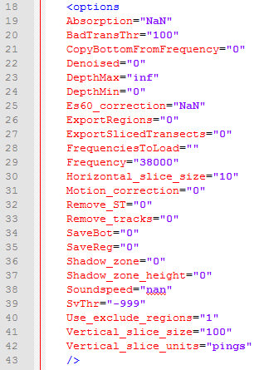

Figure : An example of complete <options ... /> element in an ESP3 script, completed with the default values

### The <cal ... /> element

The <cal ... /> element is a self-closing tag with attributes defining the calibration parameters for one frequency.

The attributes of this element and default values are (Figure 62):

* FREQ: The frequency channel to which this calibration value applies, in Hertz. Default: “38000”.
* G0: The on-axis gain for this frequency channel, in dB. Default: “25.10”.
* SACORRECT: The Sa Corr parameter for this frequency channel, in dB. Default: “0.0”.

Add and complete as many of these elements as there are frequency channels to be processed (Figure 62).

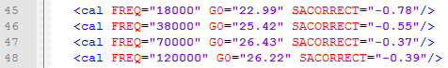

Figure : An example of several <cal … /> elements in an ESP3 script – one for each frequency channel

### The <regions\_WC ... /> element

The <regions\_WC ... /> element is a self-closing tag with attributes defining one WC region.

The attributes of this element are the same as previously described in the section of this guide about regions and illustrated in Figure 39 and Figure 40. An example of this element with all attributes defined is illustrated in Figure 63:

* y\_min: minimum range to reference line for water column region.
* y\_max: maximum range to reference line for water column region.
* Ref: reference to which the region is defined. (either "Surface" or “Bottom”)
* Cell\_w: width of cell, for units see Cell\_w\_unit.
* Cell\_h: height of cell, for units see Cell\_h\_unit.
* Cell\_w\_unit: units: "meters", “pings” or “seconds”.
* Cell\_h\_unit: units: "meters".

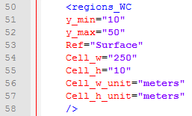

Figure : An example of complete <regions\_WC ... /> element in an ESP3 script

### The <algos> element

The <algos> element is a regular element whose contents are elements for each algorithm to be applied. These child elements are self-closing tags flagging for the application of the corresponding algorithm, and whose attributes are the parameters of the corresponding algorithm:

* <BadPingsV2 ... /> for the Bad Transmits Detection algorithm.
* <BottomDetection ... /> for the historical Bottom Detection algorithm.
* <BottomDetectionV2 ... /> for the Bottom Detection algorithm.
* <Denoise ... /> for the Data Denoising algorithm.
* <SchoolDetection ... /> for the School Detection algorithm.
* <SingleTarget ... /> for the Single Target Detection algorithm.
* <TrackTarget ... /> for the Target Tracking algorithm.

Note that algorithms will be applied in the order in which they are listed under the <algos> element, and that it is possible to apply the same algorithm as many times as desired by simply repeating the tag.

**Very important: If you operated manual editions of the bottom line, bad transmits and/or regions and wish to use them in the batch processing, you must ensure that the script does not command for the application of an algorithm that would overwrite them.** Scripts allow the application of algorithm to define bottom line, bad transmits and regions **and save the results**. If you run a script with such commands, not only will your manual editions be lost, but you may also erroneously assume the results took into account your manual editions.

#### The <BadPingsV2 ... /> element

The <BadPingsV2 ... /> element has the following attributes, corresponding to the parameters of the Bad Transmits Detection V2 algorithm:

* Above: XXX.
* BS\_std: XXX.
* BS\_std\_bool: XXX.
* Below: XXX.
* denoised: XXX.
* thr\_spikes\_Above: XXX.
* thr\_spikes\_Below: XXX.

#### The <BottomDetection … /> element

The <BottomDetection ... /> element has the following attributes, corresponding to the parameters of the Bottom Detection algorithm:

* denoised: XXX.
* horz\_filt: XXX.
* r\_max: XXX.
* r\_min: XXX.
* shift\_bot: XXX.
* thr\_backstep: XXX.
* thr\_bottom: XXX.
* vert\_filt: XXX.

#### The <BottomDetectionV2 ... /> element

The <BottomDetectionV2 ... /> element has the following attributes, corresponding to the parameters of the Bottom Detection V2 algorithm:

* denoised: The “Compute on Denoised data” parameter.
* r\_min: The “Minimum Depth” parameter.
* r\_max: The “Maximum Depth” parameter.
* thr\_bottom: The “BS Threshold” parameter.
* thr\_echo: The “Echo Threshold” parameter.
* thr\_cum: The “Cumulative Threshold” parameter.
* thr\_backstep: The “Back-step Threshold” parameter.
* shift\_bot: The “Shift Bottom” parameter.

See the section on the Bottom Detection algorithm, or the appendix, for more information.

#### The <Denoise ... /> element

The <Denoise ... /> element has the following attributes, corresponding to the parameters of the Data Denoising algorithm:

* HorzFilt: XXX.
* NoiseThr: XXX.
* SNRThr: XXX.
* VertFilt: XXX.

#### The <SchoolDetection ... /> element

The <SchoolDetection ... /> element has the following attributes, corresponding to the parameters of the School Detection algorithm:

* Sv\_max: XXX.
* Sv\_thr: XXX.
* Type: XXX.
* depth\_max: XXX.
* depth\_min: XXX.
* h\_min\_can: XXX.
* h\_min\_tot: XXX.
* horz\_link\_max: XXX.
* l\_min\_can: XXX.
* l\_min\_tot: XXX.
* nb\_min\_sples: XXX.
* vert\_link\_max: XXX.

#### The <SingleTarget ... /> element

The <SingleTarget ... /> element has the following attributes, corresponding to the parameters of the Single Target Detection algorithm:

* MaxBeamComp: XXX.
* MaxNormPL: XXX.
* MaxStdMajAxisAngle: XXX.
* MaxStdMinAxisAngle: XXX.
* MinNormPL: XXX.
* PLDL: XXX.
* TS\_threshold: XXX.
* Type: XXX.

#### The <TrackTarget ... /> element

The <TrackTarget ... /> element has the following attributes, corresponding to the parameters of the Target Tracking algorithm:

* AlphaMajAxis: XXX.
* AlphaMinAxis: XXX.
* AlphaRange: XXX.
* BetaMajAxis: XXX.
* BetaMinAxis: XXX.
* BetaRange: XXX.
* ExcluDistMajAxis: XXX.
* ExcluDistMinAxis: XXX.
* ExcluDistRange: XXX.
* IgnoreAttitude: XXX.
* MaxStdMajorAxisAngle: XXX.
* MaxStdMinorAxisAngle: XXX.
* Max\_Gap\_Track: XXX.
* Min\_Pings\_Track: XXX.
* Min\_ST\_Track: XXX.
* MissedPingExpMajAxis: XXX.
* MissedPingExpMinAxis: XXX.
* MissedPingExpRange: XXX.
* WeightMajAxis: XXX.
* WeightMinAxis: XXX.
* WeightPingGap: XXX.
* WeightRange: XXX.
* WeightTS: XXX.

### The <snapshot ... > element

The <snapshot ...> element is a regular element whose contents lists the transects to be processed. It is organized with nested elements <stratum ...> and <transect ...> (in that order) with the attributes of each element identifying the snapshot number, stratum and transect number of the transect to be processed (Figure 64). To process several transects within a stratum, several strata within a snapshot, or several snapshots, simply add these elements while following the nesting hierarchy (Figure 64).

The attributes of <snapshot ...>, <stratum ...> and <transect ...> allow identifying the transects to be processed through their metadata (see section on metadata attributes):

* number in <snapshot ...> is the snapshot number.
* folder in <snapshot ...> is the folder where the data for this snapshot arer.
* name in <stratum ...> is the stratum name.
* type in <stratum ...> restrict the type of transects to this one.
* design in <stratum ...> is the stratum design, either “hill” or “flat” (default “flat”).
* number in <transect ...> is the transect number.

Finally, the <transect ...> element has two necessary children elements <region ...> and <bottom ...>. Both those children have a ver attribute that define the version of the bottom or region that will be loaded. If version is set to -1, the bottom/region will load the .xml file, if set to 0, it will load the latest version available, either from the bottom/region database or from the .xml file if the database is empty. If set to N, it will load the database version N for those. Note that if you are loading a bottom and then apply a bottom detection algorithm, the bottom that will be applied is the one from the bottom detection. For regions, if you are loading saved schools and then apply a school detection algorithm, the schools that will be kept will be the newly detected schools.

<region ...> defines the region(s) to be echo-integrated within the transect. Use attribute name, ID, or tag to identify the region(s) of interest. Several names, IDs or tags can be combined by separating the identifier with a semi-column (for example: tag“EUP;MMU” will include all regions tagged EUP or MMU).

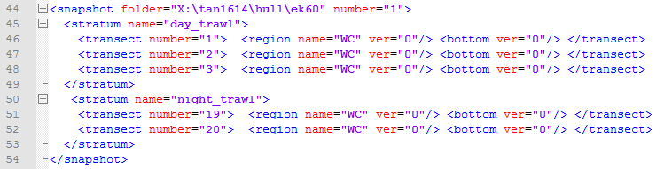

Figure : An example of a complete <snapshot> element in an ESP3 script describing the desired processing of five transects spread into two strata, all within a single snapshot.

## Survey processing results

Survey processing results are saved in a spreadsheets file titled [scriptname]\_xls\_output\_.xlsx saved in the Results folder as specified in the Path Options window (Figure 56).

It consists in four spreadsheets containing, respectively:

* Sheet1: results **metadata**
* Sheet2: **Stratum** summary.
* Sheet3: **Transect** summary.
* Sheet4: **Sliced Transect** summary.

Notation and symbols in to output files have been defined to keep consistency with our previous software ESP2, but are all derived from values computed and described in Basic echo-integration.

Note that survey processing also generates two other outputs, [scriptname]\_mbs\_output\_.txt and [scriptname]\_survey\_output\_.mat, which contain the same results in different formats, but also results at even finer level of details (not described here):

* Region summary: integration of regions in a single value. One line per region.
* Region summary (abscf by vertical slice): integration of regions in vertical slices. One line per region.
* Region vbscf: integration of a region in 2D bins. One line per region.

### Results metadata (Sheet1)

Survey processing results metadata in Sheet1 are simply a copy of the values in the <survey ...> and <options ...> elements of the script at the origin of the results (or the default values if they were not specified).

### Stratum summary (Sheet2)

Stratum summary (Sheet2) is the output of the survey processing combined into a single value for each stratum. Each row corresponds to one of the <stratum ...> elements in the script.

Those value are further explained in Appendix B: Echo-integration

For each row, the summary indicates:

* Snapshot: Snapshot number.
* stratum: Stratum name.
* no\_transects: Number of transects listed in this stratum.
* abscf\_mean: mean areal backscatter $({m^{2}m}^{-2})$.
* abscf\_sd: standard deviation of the areal backscatter.
* abscf\_wmean: weighted mean areal backscatter $({m^{2}m}^{-2})$..
* abscf\_var: variance the weighted areal backscatter.
* abscf\_with\_shz\_mean: mean areal backscatter including shadow/deadzone $({m^{2}m}^{-2})$.
* abscf\_with\_shz\_sd: standard deviation of the areal backscatter including shadow/deadzone.
* abscf\_with\_shz\_wmean: weighted mean areal backscatter including shadow/deadzone $({m^{2}m}^{-2})$.
* abscf\_with\_shz\_var: variance the weighted areal backscatter including shadow/deadzone.
* time\_start: start time of stratum survey.
* time\_end: end time of stratum survey.

### Transect summary (Sheet3)

Transect summary (Sheet3) is the output of the survey processing combined into a single value for each transect. Each row corresponds to one of the <transect ...> elements in the script.

For each row, the summary indicates:

* snapshot: Snapshot number.
* stratum: Stratum name.
* transect: Transect number.
* dist: transect distance, integrated along track (nautical miles).
* vbscf: volume backscatter for a transect $(m^{-1})$.
* abscf: transect areal backscatter $({m^{2}m}^{-2})$.
* mean\_d: mean depth of transect (m).
* pings: number of good pings in transect.
* av\_speed: average speed during transect (knots)
* start\_lat: start latitude of transect (decimal degrees).
* start\_lon: start longitude of transect (decimal degrees).
* finish\_lat: end latitude of transect (decimal degrees).
* finish\_lon: end longitude of transect (decimal degrees).
* shadow\_zone\_abscf: transect areal backscatter from shadow/deadzone $({m^{2}m}^{-2})$.
* time\_start: start transect time.
* time\_end: end transect time.
* tot\_pings: total number of pings in transects.
* nb\_tracks: number of tracks in transect.
* nb\_st: number of single targets in transect.

### Sliced transect summary (Sheet4)

Sliced transect summary (Sheet4) is the most-detailed output of the survey processing: data echo-integrated per vertical slice. The results come in blocks of 16 rows for each of the <transect ...> elements in the script.

The 16 rows indicate:

* snapshot: Snapshot number.
* stratum: Stratum name.
* transect: Transect number.
* slice\_size: The length of each slice (the unit is indicated in the results metadata).
* num\_slices: The number of slices in this transect.
* latitude: in decimal degrees.
* longitude: in decimal degrees.
* slice\_abscf: areal backscatter for slice $({m^{2}m}^{-2})$.
* time\_start: start time for cell.
* time\_end: end time for cell.
* slice\_nb\_tracks: number of tracks in slice.
* slice\_nb\_st: number of single targets in slice.
* slice\_shadow\_zone\_abscf: shadow/deadzone contribion to areal backscatter in slice $({m^{2}m}^{-2})$.
* slice\_hill\_weight: in case of star design transect (hill), weight to be applied to slice.
* latitude\_e: end latitude for slice in decimal degrees.
* longitude\_e: end latitude for slice in decimal degrees.

## Display survey processing results

* XXX
* How to plot ship tracks
  + Geographic: “Map from current layers (integrated)”

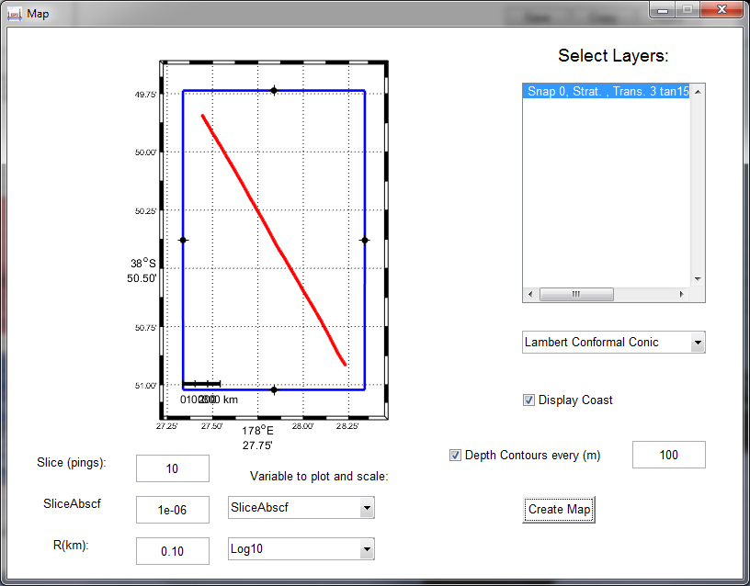

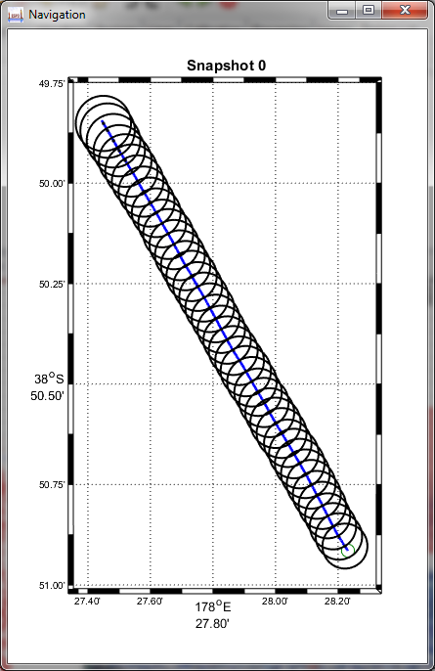

# Advanced handling

## Configurations

* XXX
* Wait for new version for config files?
* C:\Program Files\ESP3\_ver\_0.8.0.0\config

## Set paths

* XXX
* How to set
* What they do

## File input

* XXX
* Open next file / previous file
* Files tab in the main panel
* Index files
* Clean temp files

## Import/export

### GPS/attitude

### Bottom

### Regions

* export format. XXX

### Echogram

### Single targets and tracked targets

# Calibration

## CW mode:

Open loading a file, ESP3 reads the raw “Power” data and calculates the backscattering coefficient $S_{v}$ based on the two calibration parameters “Gain (dB)” and “Sa Corr (dB)” displayed in the Calibration tab of the Control panel (Figure 65). ESP3 recalculates $S_{v}$ automatically if these values are modified.

These parameters must be correct to produce a quantitatively correct $S_{v}$ and thus quantitatively correct echo-integration results. Thus, these values should always be verified before running an echo-integration calculation. If using a script, they can be specified then and do not need to be specified as such.

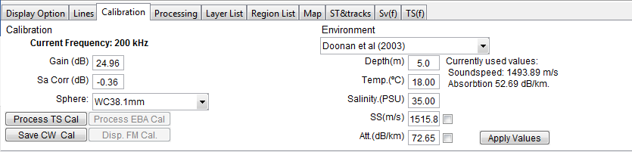

Figure : The "Calibration" tab in the Control Panel. The calibration parameters “Gain (dB)” and “Sa Corr (dB)” are automatically used to calculate the $S_{v}$ displayed. All other settings and buttons can be used to determine new calibration parameters, and discussed in a later section

In order to recalculate those two parameters using calibration data, use the following sequence.

First, set appropriate parameters in the Environment sub-panel. Usually:

* Set the temperature in Celsius degrees (at NIWA, take mean temperature from table 2 in calibration analysis document) and the salinity in PSU (at NIWA, take the mean salinity from table 2 in calibration analysis document).
* ESP3 calculates attenuation and sound speed using the method indicated in the drop-down menu (Doonan et al 2003, or Francois and Garrison 1982). Use the values calculated or overwrite them by checking the check box next to those values. At NIWA, table 2 in calibration analysis document provides sound absorption and sound speed values.
* Click Apply Values to record these parameters and recompute the $S_{v}$ values.

Next, define one or several regions around the sphere echo in the echogram.

Next, run the calibration:

* Click on Reprocess in the Calibration tab.
* The results are in the command window and in a text file exported automatically in the same folder as raw data, and titled “Cal\_logXXX000.txt” where XXX is the frequency (e.g. “Cal\_log38000.txt” for 38 kHz).
* The two major results are:
  + The gain, found at line 16 in the text file: “So the calibrated G\_o = XXX dB (mean method)”.
  + The Sa Corr, found at line 26 in the text file: “So sa correction = XXX dB”.
* Other values relevant to NIWA procedure:
  + Beamwidth (°) along: “Fore/aft beamwidth = XXX degrees” (line #28).
  + Beamwidth (°) athwartship: “Port/stbd beamwidth = XXX degrees” (line #30).
  + Beam offset (°) along: “Fore/aft offset = XXX degrees (to be subtracted from EK60 angles)” (line #29).
  + Beamwidth (°) athwartship: “Port/stbd offset = XXX degrees (to be subtracted from EK60 angles)” (line #31).
  + RMS deviation (dB): “RMS of fit to beam model out to XXX degrees = XXX dB” (line #35).

Finally, set the values for the “Gain (dB)” and “Sa Corr (dB)” parameters in the fields provided in the Calibration tab.

# Other algorithms

## Denoising

Parameters:

* Horz. Filt.(nb pings): XXX. Default:
* Vert. Filt.(m) : XXX. Default:
* Noise Level Thr(db) : XXX. Default:
* SNR Thr(dB) : XXX. Default:

## School classification

XXX

## Single Targets detection

Parameters:

* TS thr(dB): XXX. Default: -70
* Max. Beam Comp.: XXX. Default: 12
* Δ Along Angle (°): XXX. Default: 1.0
* Δ Across Angle (°): XXX. Default: 1.0
* PLDL(dB): XXX. Default: 6
* Min Norm PL: XXX. Default: 0.8
* Max Norm PL: XXX. Default: 1.2

## Target tracking

* XXX
* Target tracking algorithm
* ST&tracks
* Set a region from tracks

Parameters:

* Alpha/Beta tracking
  + Alpha Al.: XXX. Default: 0.5
  + Alpha Ac. : XXX. Default:0.5
  + Alpha R. : XXX. Default:0.5
  + Beta Al. : XXX. Default:0.3
  + Beta Ac. : XXX. Default:0.3
  + Beta R. : XXX. Default:0.3
  + Excl dist(m) Al. : XXX. Default:1
  + Excl dist(m) Ac. : XXX. Default:1
  + Excl dist(m) R. : XXX. Default:1
  + Angle Uncert.() Al. : XXX. Default:1
  + Angle Uncert.() Ac. : XXX. Default:1
  + Ping exp(%) Al. : XXX. Default:5
  + Ping exp(%) Ac. : XXX. Default:5
  + Ping exp(%) R. : XXX. Default:5
* Weights:
  + Along: XXX. Default:20
  + Across: XXX. Default:20
  + Range: XXX. Default:40
  + TS: XXX. Default:20
  + Ping Gap: XXX. Default:0
* Track acceptance
  + Min ST #: XXX. Default:5
  + MinPings #: XXX. Default:5
  + MaxPingGap #: XXX. Default:3
  + Ignore Attitude: XXX. Default: check

# Appendix A: Algorithms

## Bottom detect v2

### Location

This algorithm can be found in MATLAB file:

\algos\bottom\_detection\detec\_bottom\_algo\_v4.m

### Description

The following sequence summarizes the algorithm principles. Details and order may vary in the application.

Step 1: Source data choice

The **“Compute on Denoised data”** parameter (denoised, 0 by default) controls whether the algorithm is applied to the normal “TS (uncompensated)” data (denoised=0) or after it was denoised, aka “Denoised Sp” (denoised=1).

Whatever the choice, data are transformed into surface-equivalent backscatter for the rest of the algorithm ( $BS=TS-10\log_{10}\left(R\right)$ where *TS* is the uncompensated Target Strength and *R* is the range).

Step 2: Data cropping

Data are cropped in depth, as controlled by the **“Minimum Depth”** parameter (r\_min, 0 by default) and the **“Maximum Depth”** parameter (r\_max, “infinite” by default). Ringdown is also removed from the data.

Pings for which the maximum *BS* level is less than the **“BS Threshold”** parameter (thr\_bottom, -35 by default) are discarded from the algorithm. This threshold is to prevent detecting a bottom in pings where the bottom was out of data range, or data where cavitation or other technical issue prevented the recording of a strong bottom echo.

* Changing this parameter will therefore not change the location of the detected bottom in any given ping, but which pings it is applied to.
* Use a sufficiently low **“BS Threshold”** to force the algorithm to be applied to all pings even if they show a weak bottom echo.
* Make **“BS Threshold”** higher if you wish to prevent the algorithm to be applied to pings that don’t have a clear bottom echo.

Step 3: Finding a first bottom sample

To find a bottom sample, the algorithm first limits the data analysed to the samples that have a BS value that exceeds a threshold defined by the maximum BS in a ping plus the **“Echo Threshold”** parameter (thr\_echo, -35 by default). For example, if the maximum BS value in a ping is -28.7 dB and the parameter is set at its default value of -35 dB, the algorithm will proceed with samples with a value of at least -28.7-35 = -63.7 dB.

* Changing this parameter does change the location of the bottom sample in any given ping, but its influence is limited unless there are strong echoes in the water column above the bottom.
* Increase the value from the default -35 dB to force the algorithm to omit strong water-column echoes.

Next, the algorithm calculates the normalized, cumulative sum of the squared of the remaining data BS in linear values, that is:

$$s\left(t\right)= \frac{\int_{0}^{t}{{bs}^{2}\left(x\right)dx}}{\int_{0}^{T}{{bs}^{2}\left(x\right)dx}}$$

Where $bs={10}^{\frac{BS}{10}}$, *T* is the total duration of the signal in the remaining data.

Finally, the algorithm will define the candidate bottom sample in this normalized cumulative signal as the first sample above the **“Cumulative Threshold”** parameter (thr\_cum, 1 by default). Note that this parameter is in percentages, aka if thr\_cum=1, the algorithm will find the first sample above 0.01 in the normalized, cumulative signal.

* Appropriate values for this parameter range between 0.01 and 1, because the bottom echo contains the overwhelming majority of the energy in a ping. Using higher values risks defining the bottom sample well within the bottom echo.
* The higher this parameter, the closer to the bottom echo will the bottom sample be defined.

Step 4: Recursive back-stepping

The algorithm then searches within one pulse length above the detected bottom sample if there are any sample for which the difference in BS with the bottom sample is less than the **“Back-step Threshold”** parameter (thr\_backstep, -1 by default). If this occurs, this sample becomes the new detected bottom sample and the process is repeated. The recursive process stops when the difference in BS between the bottom sample and the sample above at one pulse length is greater than the **“Back-step Threshold”** parameter.

This process allows finding the closest sample from the initial detection that represents a significant step-up in signal strength.

* This is the most sensitive parameter of the list. Modify carefully.
* Use 0 to prevent the algorithm from back-stepping.
* Lower this value to -3, or -5, or further, when the signal above the bottom is rather strong (sidelobe artefact, for example) and you want your bottom sample to be defined above this fuzzy zone.

Step 5: Bottom shifting

Finally, the algorithm steps back the bottom even further by the constant distance informed by the **“Shift Bottom”** parameter (shift\_bot, 0 by default).

## Bad Pings Detection

### Location

The Bad Pings Detection algorithm can be found in MATLAB file:

\algos\bad\_transmit\bad\_pings\_removal\_3.m

### Description

This algorithm consists of five sub-algorithms in one:

* The undefined bottom-line analysis;
* The ringdown analysis;
* The bottom-echo backscatter analysis;
* The above-bottom-echo backscatter analysis; and
* The below-bottom-echo backscatter analysis.

Only the first one (the undefined bottom-line analysis) is systematically applied, while all others are only applied if called in input. ESP3 detect bad pings with each of these algorithms and combine the results in output. Therefore, the more of these sub-algorithms are called in input, the more bad pings will be detected.

Sub-algorithm #1: The undefined bottom-line analysis

This sub-algorithm flags as bad pings all pings for which the bottom-line is undefined, unless they come in a block of six or more consecutive pings (Figure 66). This algorithm has no controllable parameter.

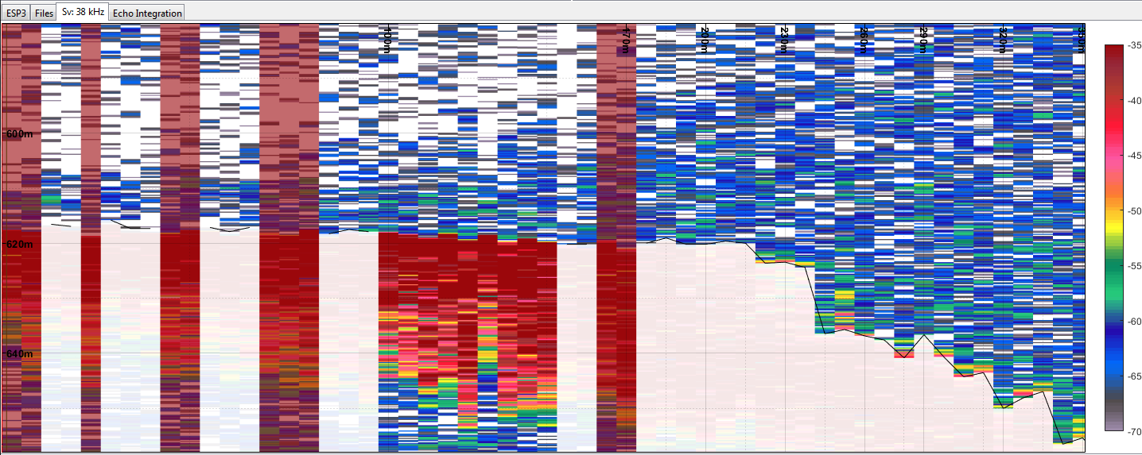

Figure : Result of the application of the undefined bottom-line analysis sub-algorithm of the Bad Pings Detection algorithm, targeting pings with undefined bottom line.

Sub-algorithm #2: The ringdown analysis

Under normal conditions, the ringdown (i.e. the recording of the pulse as it is being transmitted) is very stable. Abnormal values are indicative of issues in transmitted power, often due to cavitation. This sub-algorithm analyses the ringdown for abnormal power level.

The **“Ringdown Analysis Flag”** parameter (Ringdown\_std\_bool, 1 by default) controls whether the sub-algorithm is applied (Ringdown\_std\_bool=1) or not (Ringdown\_std\_bool=0).

The sub-algorithm finds and extracts in each ping the raw level sample (Power) corresponding to approximately a third of the pulse length. Two analyses are then performed on this sample over all pings. First, the algorithm computes a histogram of all samples, takes the maximum value as the ringdown nominal value, and flags all samples that differ from the nominal value by more than twice the “**Ringdown Deviation Threshold**” parameter (Ringdown\_std, 0.05 by default). Then, to account for the possibility of the transmitted power changing over time, a similar analysis is applied in which a sliding subset of samples are considered instead of the full set. Histograms are computed on those subsets, nominal values are defined as the average of the highest values in each histogram, and the algorithm flags all samples than differ from the nominal value by the “**Ringdown Deviation Threshold**” parameter.

Accordingly, the lower the “**Ringdown Deviation Threshold**” parameter, the more sensitive is this algorithm, and the more pings will be flagged as bad pings.

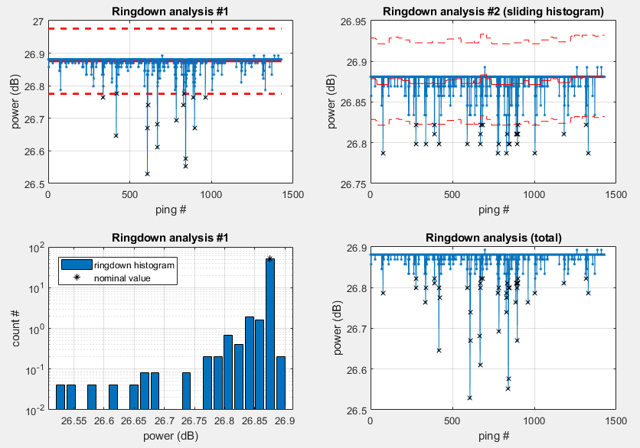

Figure : Example of results from the ringdown analysis

Sub-algorithm #3: The bottom-echo backscatter analysis

A common symptom of a ping that was not transmitted correctly throughout the water column is a bottom echo that is significantly weaker or stronger than normal. This sub-algorithm analyses the bottom echo for such abnormal values.

The **“Bottom Echo Analysis Flag”** parameter (BS\_std\_bool, 1 by default) controls whether the sub-algorithm is applied (BS\_std\_bool=1) or not (BS\_std\_bool=0).

The algorithm starts by transforming data into “pseudo-backscatter” surface-equivalent backscatter ( $BS=Sv+10\log_{10}\left(R\right)$ where *Sv* is the volume backscattering strength and *R* is the range). It then calculates the average value (in linear space) of the bottom echo approximated as all samples between the bottom detect and the sample at the range corresponding to 110% of the bottom detect range. The algorithm then computes a running average over two windows of 3 and 5 pings, and flag as bad pings those whose moving average exceeds the “**Bottom Echo Deviation Threshold**” parameter (BS\_std, 6 by default).

Accordingly, the lower the “**Bottom Echo Deviation Threshold**” parameter, the more sensitive is this algorithm, and the more pings will be flagged as bad pings.

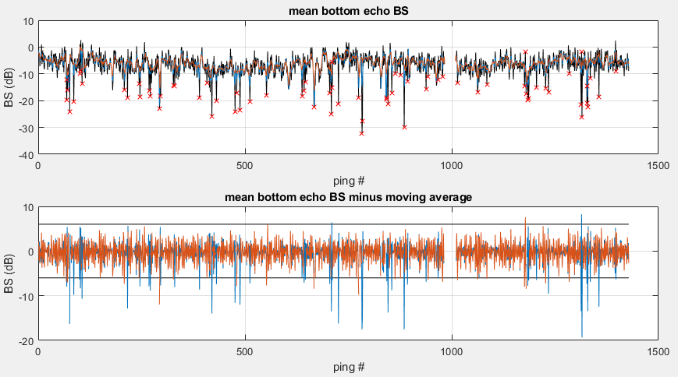

Figure : Example of results from the bottom echo backscatter analysis

Sub-algorithm #4: The above-bottom-echo backscatter analysis

This algorithm analyses the average backscatter data in the water column between the end of the ringdown and the bottom detect for abnormally strong or abnormally weak level.

The **“Above-Bottom-Echo Analysis Flag”** parameter (Above, 1 by default) controls whether the sub-algorithm is applied (Above=1) or not (Above=0).

The algorithm starts from the same surface-equivalent backscatter calculated previously. It then calculates the average value (in dB space) of the section of data between the ranges corresponding to the end of the ringdown and the bottom detect, if the algorithm is applied to the entire data. If applied to a region, the entire section of data above the bottom detect will be considered. A peak detection algorithm is then applied to identify individual pings (or groups of 2 to 3 pings) with a level higher than its neighbours by more than the “**Above-Bottom-Echo Deviation Threshold**” parameter (thr\_spikes\_Above, 3 by default). The process is repeated to identify negative peaks.

Accordingly, the lower the “**Above-Bottom-Echo Deviation Threshold**” parameter, the more sensitive is this algorithm, and the more pings will be flagged as bad pings.

Sub-algorithm #5: The below-bottom-echo backscatter analysis

This algorithm analyses the average backscatter data in the water column between the end of the bottom echo and the first multiple return for abnormally weak level.

The **“Below-Bottom-Echo Analysis Flag”** parameter (Below, 0 by default) controls whether the sub-algorithm is applied (Below=1) or not (Below=0).

The algorithm starts from the same surface-equivalent backscatter calculated previously. It then calculates the average value (in dB space) of the section of data between the ranges corresponding to 110% of the bottom detect range and the first bottom multiple, if the algorithm is applied to the entire data. If applied to a region, the entire section of data below the range corresponding to 110% of the bottom detect range is considered. The peak detection algorithm is then applied to identify individual pings (or groups of 2 to 3 pings) with a level lower than its neighbours by more than the “**Below-Bottom-Echo Deviation Threshold**” parameter (thr\_spikes\_Below, 3 by default).

Accordingly, the lower the “**Below-Bottom-Echo Deviation Threshold**” parameter, the more sensitive is this algorithm, and the more pings will be flagged as bad pings.

Note that this sub-algorithm is very sensitive if there are few data below the bottom echo.

# Appendix B: Echo-integration

This section contains the echo-integration formulae used in ESP3.

## Preliminary definitions

In the following, we consider an echogram defined as a set of contiguous data samples $S=\left\{1,2,…,m\right\}$ for a set of contiguous pings $P=\left\{1,2,…,n\right\}$.

The distance (in m) between two consecutive data samples $i$ and $i+1$ in $S$ is given by:

|  |  |  |
| --- | --- | --- |
|  | $$d_{i}=\frac{c_{i}}{{2f}_{S}}$$ | (1) |

where $f_{S}$ is the sampling frequency (in Hz), and $c_{i}$ is the average sound velocity (in m/s) at the samples’ location.

In ESP3, a “cell” is a contiguous subarray of the echogram defined by the indices of its first sample and first ping $i∈S$ and $j∈P$, respectively, and the number of samples $m_{C}$ in the samples dimension (“height”) and the number of pings in the pings dimension $n_{C}$ (“width”). It can be written as:

|  |  |  |
| --- | --- | --- |
|  | $$C=\left\{i,i+1,…, i+m_{C}-1\right\}∈S,\left\{j,j+1,…, j+n_{C}-1\right\}∈P$$ | (2) |

Assuming the sound velocity is constant within a cell, the total height (in m) of a cell is thus:

|  |  |  |
| --- | --- | --- |
|  | $$d_{C}=m_{C}.d_{i}$$ | (3) |

Not all samples within a cell are taken into account in the echo integration. In ESP3, there are four conditions under which a sample would be considered “invalid” and removed from integration calculations:

* The sample is part of a ping flagged as a “bad transmit”;
* The sample is at or beyond the “bottom line”;
* The sample is within a region flagged as “bad data”, or;
* The sample is outside of the set “depth boundaries”.

We note $C^{*}$ the subset of $C$ that is composed of the samples of $C$ that are “valid”. Moreover, we note $n_{c}^{*}$ the number of pings in cell $C$ that were not flagged as “bad transmit”, that is the number of “valid pings”.

## Backscattering coefficients for a cell

The area backscattering coefficient $s_{a}$ for a sample $i$ is the product of its volume backscattering coefficient $s_{v}$ and the height of that sample:

|  |  |  |
| --- | --- | --- |
|  | $$s_{a}\left(i\right)=s_{v}(i).d_{i}$$ | (4) |

The area backscattering coefficient for a cell $C$ is the sum of the area backscattering coefficient of all valid samples in the cell:

|  |  |  |
| --- | --- | --- |
|  | $$s_{a}\left(C\right)=\sum_{i∈C^{*}}{s_{a}(i)}$$ | (5) |

The corresponding volume backscattering coefficient is:

|  |  |  |
| --- | --- | --- |
|  | $$s_{v}(C)=\frac{s_{a}(C)}{n_{c}^{*}.d_{C}}$$ | (6) |

The proportion of valid samples within the cell is calculated as:

|  |  |  |
| --- | --- | --- |
|  | $$PRC(C)=\frac{\sum_{C^{*}}{d_{i}}}{n_{c}^{*}.d_{C}}$$ | (7) |

## Area and volume backscatter for a region

A region is any set of samples from an echogram. They are typically defined for a mark or a whole depth interval in the water column and are thus usually larger than cells.

The mean volume backscatter coefficient for a region is given by

|  |  |  |
| --- | --- | --- |
|  | $$s_{v}(R)=\frac{\sum_{C∈R}{s_{a}\left(C\right)}}{\sum_{C∈R}{n_{c}^{*}.d_{C}}}$$ | (8) |

The mean area backscatter coefficient per ping for a region is given by:

|  |  |  |
| --- | --- | --- |
|  | $$\hat{s_{a}}(R)=\frac{\sum_{C∈R}{s_{a}\left(C\right)}}{n_{R}^{*}}$$ | (9) |

Where $n_{R}^{*}$ is the number of pings in region $R$ that were not flagged as “bad transmit”.

## Sliced area backscatter for a transect

The mean area backscatter coefficient per ping for a slice is given by:

|  |  |  |
| --- | --- | --- |
|  | $$\hat{s_{a}}(S)=\frac{\sum_{C∈S}{s_{a}\left(C\right)}}{n_{S}^{*}}$$ | (10) |

Where $n_{S}^{*}$ is the number of pings in slice $S$ that were not flagged as “bad transmit”.

## Volume backscatter for a file

The volume backscatter for a file is given by

|  |  |  |
| --- | --- | --- |
|  | $${vbscf}_{F}=\frac{\sum_{R}{\sum_{S}{\left(e_{i}.η\right)}}}{δ.p}$$ | (11) |

where $e_{i}$ is the echo integral for slice $i$, $η$ the echo integral correction factor, $δ$ the mean bottom depth (in metres) in the file, and $p$ the number of good transmits in the file. The summations are over all the regions in a file, and all of the selected slices in a region respectively. The mean bottom depth and the number of good transmits can vary depending on the “region span flag”.

When set to “off” (the default), the mean bottom depth and good transmits are over the entire file. When set to “on”, they are constrained to be from the start of the leftmost region to the end of the rightmost region in the file.

## Areal backscatter for a file

The areal backscatter for a file is given by

|  |  |  |
| --- | --- | --- |
|  | $$a{bscf}_{F}=\frac{\sum_{R}{\sum_{S}{\left(e_{i}.η\right)}}}{p}$$ | (12) |

where the symbols are as given above.

## Volume backscatter for a transect

The volume backscatter for a transect is given by

|  |  |  |
| --- | --- | --- |
|  | $${vbscf}_{T}=\frac{\sum_{F}{\sum_{R}{\sum_{S}{\left(e_{i}.η\right)}}}}{\sum_{F}{\left(δ.p\right)}}$$ | (13) |

where the symbols are as given above. The summation over $F$ refers to summation over all of the files in a transect.

## Areal backscatter for a transect

The areal backscatter for a transect is given by

|  |  |  |
| --- | --- | --- |
|  | $$a{bscf}_{T}=\frac{\sum_{F}{\sum_{R}{\sum_{S}{\left(e_{i}.η\right)}}}}{\sum_{F}{\left(p\right)}}$$ | (14) |

where the symbols are as given above.

## Areal backscatter for a stratum

The areal backscatter for a stratum is the mean of the areal backscatter of all transects composing the stratum:

|  |  |  |
| --- | --- | --- |
|  | $${abscf}_{S}=\frac{\sum_{T}{{abscf}_{i}}}{n}$$ | (15) |

where ${abscf}_{i}$ is the areal backscatter for transect $i$, the summation is over all transects in the stratum, and $n$ is the number of transects in the stratum.

The standard deviation of the areal backscatter of a stratum is given by:

|  |  |  |
| --- | --- | --- |
|  | $$s.d.=\sqrt{\frac{\sum_{T}{{abscf}_{i}^{2}}-\frac{{\left(\sum_{T}{{abscf}_{i}}\right)}^{2}}{n}}{n-1}}$$ | (16) |

where ${abscf}_{i}$ is the areal backscatter for transect $i$, the summation is over all transects in the stratum, and $n$ is the number of transects in the stratum. In the case where there is only one transect, the standard deviation is zero.

The weighted mean areal backscatter for a stratum is given by:

|  |  |  |
| --- | --- | --- |
|  | $$a{bscf}_{S_{w}}=\frac{\sum_{T}{\left(d_{i}.{abscf}_{i}\right)}}{\sum_{T}{\left(d_{i}\right)}}$$ | (17) |

where ${abscf}_{S_{w}}$ is the weighted areal backscatter for the stratum, ${abscf}_{i}$ is the areal backscatter for transect $i$, and $d_{i}$ is the distance (in nautical miles) of transect $i$, and the summations are over all transects in the stratum. If the region span flag is on something unknown will happen.

The variance is given by:

|  |  |  |
| --- | --- | --- |
|  | $$var=\left[\sum_{T}{\left(d_{i}^{2}.{abscf}_{i}^{2}\right)}-2.{abscf}_{S_{w}}.\sum_{T}{\left(d_{i}^{2}.{abscf}_{i}\right)}+{abscf}_{S_{w}}^{2}.\sum_{T}{d_{i}^{2}}\right]\frac{n}{\left(n-1\right){\left(\sum_{T}{d_{i}}\right)}^{2}}$$ | (18) |

The variables have the same meanings as for the weighted mean formula. When there is only one transect in the stratum, the variance is zero. Note that the above formula for the variance is identical to that given in Coombs and Cordue (1995).

# References

Coombs RF, Cordue PL (1995) Evolution of a stock assessment tool: acoustic surveys of spawning hoki (*Macruronus novaezelandiae*) off the west coast of South Island, New Zealand, 1985-91. New Zealand Journal of Marine and Freshwater Research 29:175-194.

MacLennan DN, Fernandes PG, Dalen J (2002) A consistent approach to definitions and symbols in fisheries acoustics. ICES J. Mar Sc. 59: 365-369. Doi:10.1006/jmsc.2001.1158

Dunford, A. J. (2005). Correcting echo-integration data for transducer motion. *The Journal of the Acoustical Society of America, 118*(4), 2121. doi:10.1121/1.2005927